Money math addition and subtraction

Example:

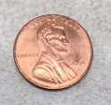 +
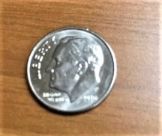 = 25¢

Add up the coins and determine the total amounts:

= ____¢

 
   





   

