Match game playing cards
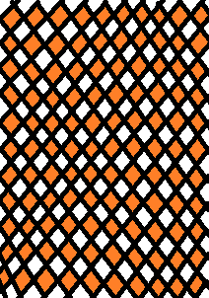
A | A | A | A
B | B | B | B
C | C | C | C
D | D | D | D
E | E | E | E
F | F | F | F
G | G | G | G
H | H | H | H
I | I | I | I
J | J | J | J
K | K | K | K
L | L | L | L
M | M | M | M
N | N | N | N
O | O | O | O
P | P | P | P
Q | Q | Q | Q
R | R | R | R
Z | Z | Z | Z
S | S | S | S
T | T | T | T
U | U | U | U
V | V | V | V
W | W | W | W
X | X | X | X
Y | Y | Y | Y

