Money Numbers
1 penny = 1 cent
5 cents = 1 nickel
2 nickels = 1 dime
10 pennies = 1 dime
2 dimes + 1 nickel = 1 quarter
5 nickels = 1 quarter
25 pennies = 1 quarter
2 quarters = 1 half dollar
10 nickels = 1 half dollar
5 dimes = 1 half dollar
50 pennies = 1 half dollar
100 pennies = 1 dollar
20 nickels = 1 dollar
10 dimes = 1 dollar
4 quarters = 1 dollar
2 half dollars = 1 dollar
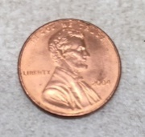 =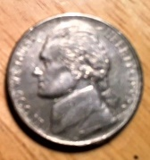
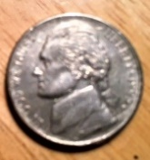 =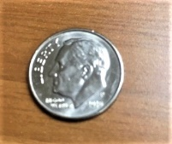
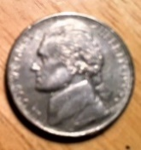 =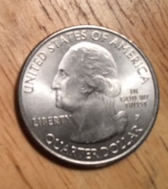
=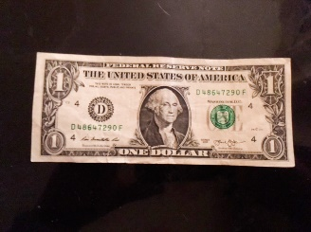
=
1 cent = 1¢
5 cents = 5¢
10 cents = 10¢
1 dollar = $1.00
2 dollars = $2.00
5 dollars = $5.00
8 dollars and fifty cents = $8.50
7 dollars and 35 cents = $7.35
16 dollars and 22 cents = $16.22
125 dollars and 46 cents = $125.46

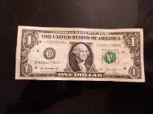 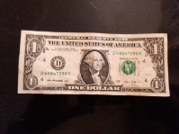 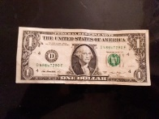 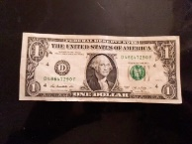 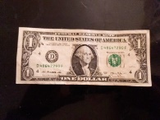 = 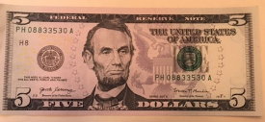

= 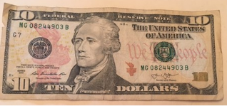

+ =

0 1 2 3 4 5 6 7 8 9 10 11 12 13 14 15 16 17 18 19 20

1 1
$ 2.58
+$ 3.96
$ 6.54

1 1 1
$ 12. 39
+$ 237. 65
$ 250. 04

0 1 2 3 4 5 6 7 8 9 10 11 12 13 14 15 16 17 18 19 20

$ 4. 74
-$ 2. 53
$ 2. 21

4
$ 15.¹37
-$ 12. 84
$ 2. 53

0 1 2 3 4 5 6 7 8 9 10 11 12 13 14 15 16 17 18 19 20

3¹6
$ 247.¹48
-$ 139.56
$ 107.92

1 1 1 1 1
$ 3762. 96
+$ 4539. 35
$ 8302. 31

0 1 2 3 4 5 6 7 8 9 10 11 12 13 14 15 16 17 18 19 20

$ 1. 45 $ .72 $ 6. 35 $ 3. 25 $ 9.00
+$ . 33 +$ 2.15 +$ 3. 44 +$ 7. 61 +$ 2.78

$ 6. 95 $ 4. 77 $ 7. 28 $ 10. 75 $ 86. 48
+$ 2. 04 +$ 3. 55 +$ 5. 94 +$ 25. 54 +$ 37. 52

$ 9. 74 $ 5. 62 $ 6. 03 $ 25.00 $ 15.67
-$ 5. 42 -$ 3. 40 -$ 4. 72 -$ 13.27 -$ 12.59

0 1 2 3 4 5 6 7 8 9 10 11 12 13 14 15 16 17 18 19 20

$ 89. 45 $ 32. 59 $ 70. 44 $ 99. 37 $ 76. 85
-$ 37. 66 -$ 21. 37 -$ 55. 33 -$ 66. 84 -$ 55. 38

