Match game playing cards
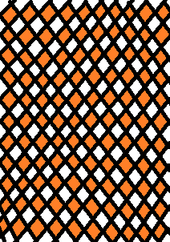
1 | 1 | 2 | 2
3 | 3 | 4 | 4
5 | 5 | 6 | 6
7 | 7 | 8 | 8
9 | 9 | 10 | 10
11  13 | 11  13 | 12 | 12
15 | 15 | 16 | 16
17 | 17 | 18 | 18
14 | 14 | 19 | 19
20 | 20 | 21 | 21
22 | 22 | 23 | 23
24 | 24 | 25 | 25
+ | + | - | -
⁼  26 | ⁼ | ÷ | ÷
26

