Choose the letters, pictures, or words that are the same as the first letter, picture, or word:
A A D A E Y V A T A N M
E P F G B E K E S Z E X
O D G C O P Q O B C O R
W N M W V Y W H X W V M
T I J L T F J T K T E L
H E N H X K H N T H P R
C D C O Q G B C S D O C
F H E F K R F Z F P R F
L L F E Y T L R F L K P
U V Y M U W X J U X U V
R P B H R P R T G R Q G
Y T V W Y X K Y N F Y V
M N M V W X Z M H M N W
D O G D C Q R D B P D Q
S Z N H K S X Z S N F S
I J K I T L I V I L J I
P B R P F E P Y S P B R
a a d a e y v a t a n m
e p f g b e k e s z e x
o d g c o p q o b c o r
w n m w v y w h x w v m
t i j l t f j t k t e l
h e n h x k h n t h p r
c d c o q g b c s d o c
f h e f k r f z f p r f
l i f e y t l r f l k p
u v y m u w x j u x u v
r p b h r p r t g r q g
y t v w y x k y n f y v
m n m v w x z m h m n w
d o g d c q r d b p d q
s z n h k s x z s n f s
i j k i t l i v i l j i
p b r p f e p y s p b r

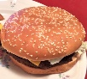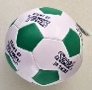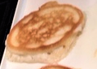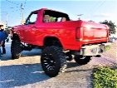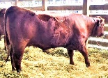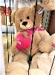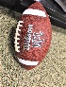
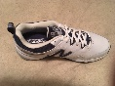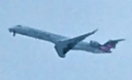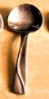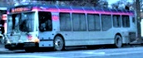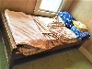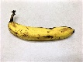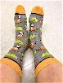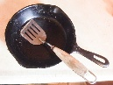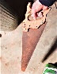
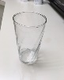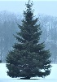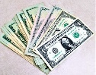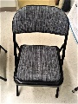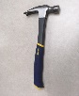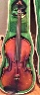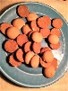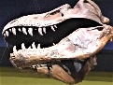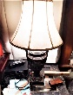
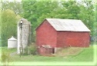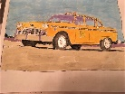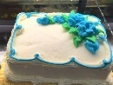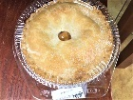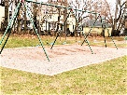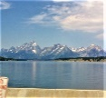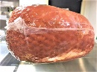

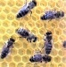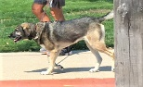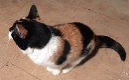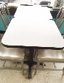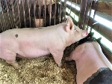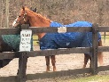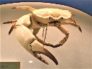
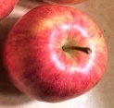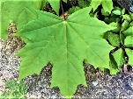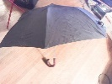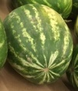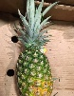
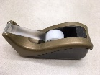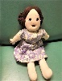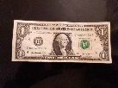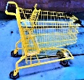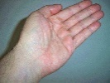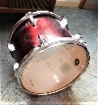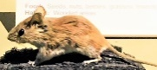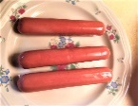
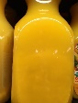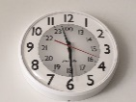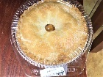
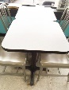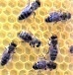
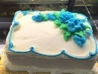

Cup Dog Car Cup Girl Farm Up Star Cup Ear Cup Art
See Nose See Bean Toe Hand See Lamb Post See Van Mom
Peas Oven Week Peas Dad Deer Peas Cow Near Sand Week Peas
Walk Put Walk Do Far Top Saw Walk News Walk Hair Leg
Dad Fun Foot Dad Work Bus Day Dad Sun Fan Dad Ham
Cat Food Head Road Bike Cat Sink Pot Cat Eat Swim Cat
Pear Noon Lip Pear Skin Desk Can Pear Pen Use Pear Note
Like Soon Shoe Like Hose Map Hill Fish Like Make Nail Like
Meat Book Time Band Meat Bag Meat Fast Meat Slow Cook Pan
Lamp Show Seat Lamp Big Hurt Lamp Old Nice Use Lamp Pig
Zoo Cage Zoo Path Lake Bear Lion Zoo Sky Each Zoo Nap
Step Door Fur Step Ball Boy Inch Step Worm Dirt Step Barn
Say Hear Say Talk Tap Bite Say Why Word Sip Say Fort
Key Yes No Key Part Pail Key Cord Wet Swim Key Plug
When Now Push Move When Pond Dry Lime When Milk Stir When
Fix Make Fix Bun Cute Comb Fix Wash Nail Tack Fix Down
Hole Dent Hole Some Face Hole Help Care Hole Pick Team Out

