Time Numbers

60 seconds = 1 minute
120 seconds = 2 minutes
60 minutes = 1 hour
120 minutes = 2 hours
24 hours = 1 day
48 hours = 2 days
28-31 days = 1 month
365 days = I year
7 days = 1 week
Sunday, Monday, Tuesday.
Wednesday. Thursday, Friday
Saturday
52 weeks = 1 year
4 weeks = 1 month (approximately)
January, February, March, April,
May, June, July, August,
September, October, November,
December
12 months = 1 year
10 years = 1 decade
10 decades = 1 century

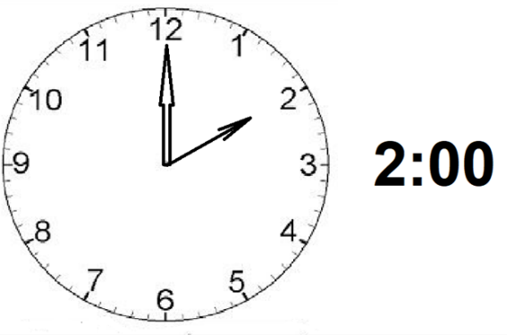
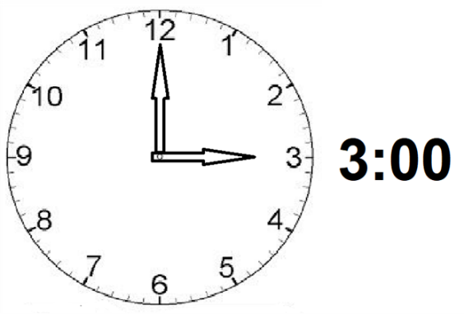
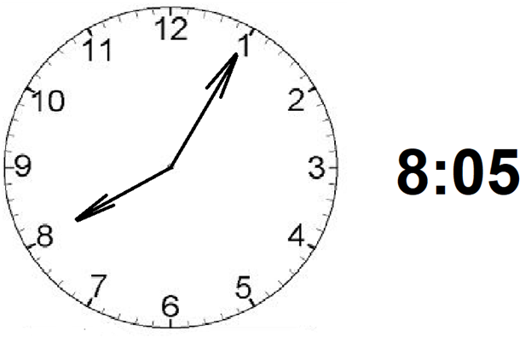
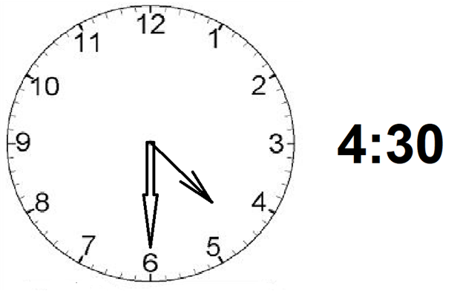
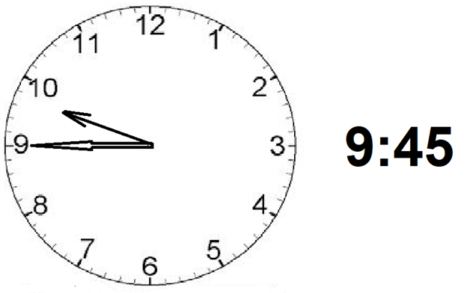
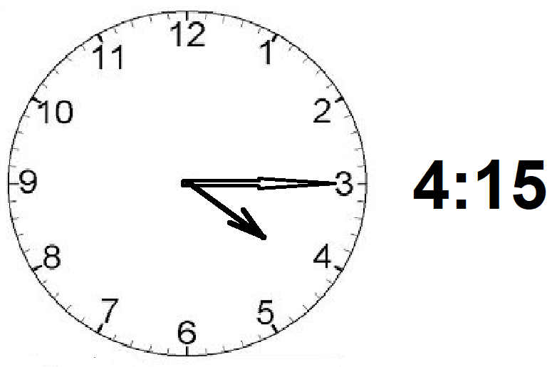
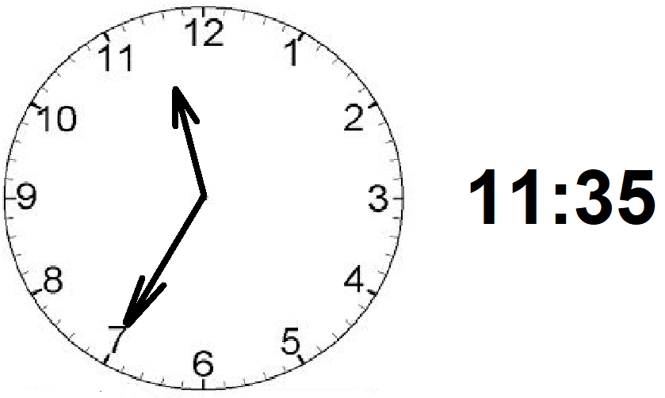
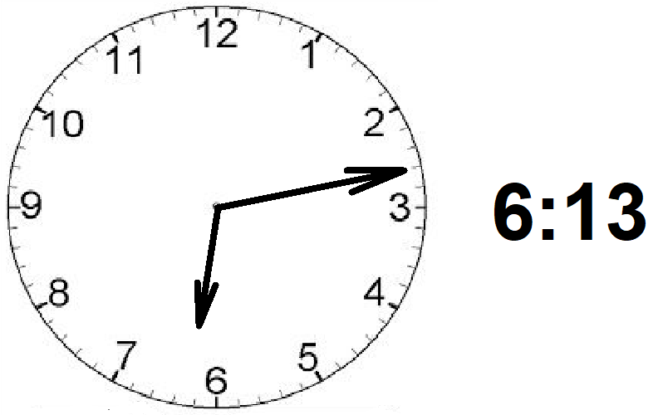
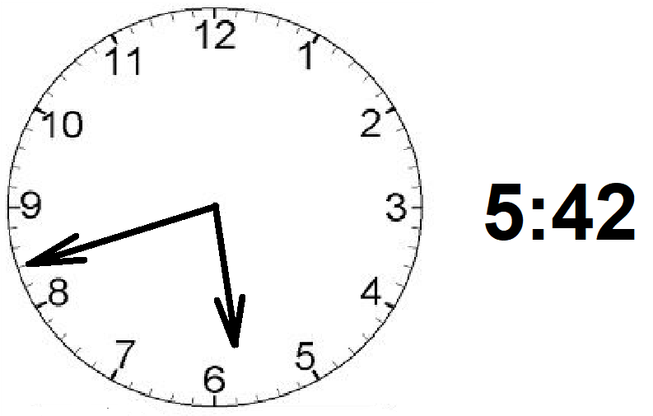
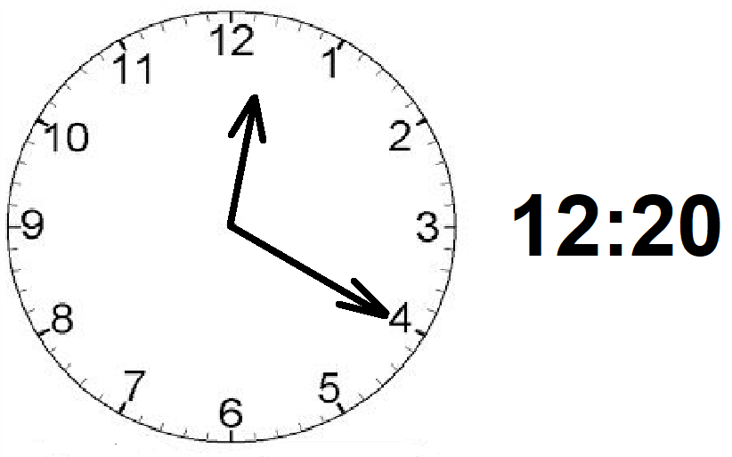
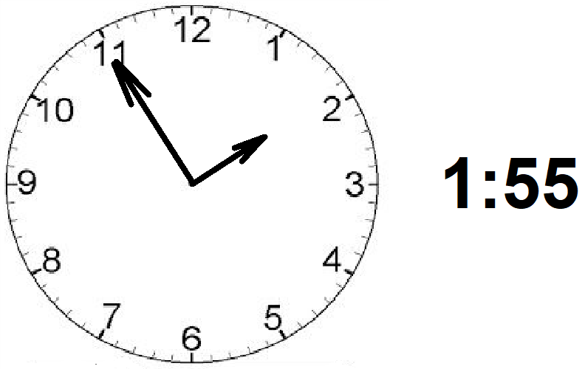

1
25 minutes
+ 45 minutes
70 minutes (= 1 hour & ten minutes)
1 1
3 hours and 49 minutes
+ 2 hours and 36 minutes
(5 hours and 75 minutes)
or
6 hours and 15 minutes

