Match game playing cards
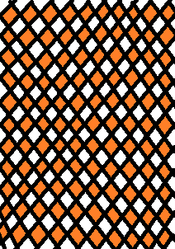
A | A | B | B
C | C | D | D
E | E | F | F
G | G | H | H
I | I | J | J
K | K | L | L
M | M | N | N
O | O | P | P
Q | Q | R | R
S | S | T | T
U | U | V | V
W | W | X | X
Y | Y | Z | Z
? | ? | ! | !
$ | $ | % | %

