0 1 2 3 4 5 6 7 8 9 10 11 12 13 14 15 16 17 18 19 20
Subtraction pictures: Write the answers to the picture subtraction items:
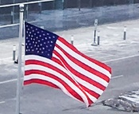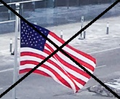
8 3
8 (eight) Flags minus (-) 3 (three) flags equals (=) ___________.

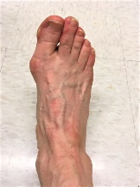
5 2
5 (five) feet minus (-) 2 (two) feet equals (=) ________.
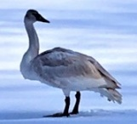
4
9
0 1 2 3 4 5 6 7 8 9 10 11 12 13 14 15 16 17 18 19 20
9 (nine) geese minus (-) 4 (four) geese equals (=) ______.
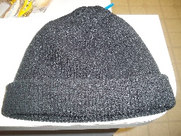
5 0
5 (five) hats minus (-) 0 (zero) hats equals (=) _________.

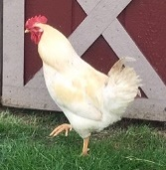
10 2
10 (ten) hens minus (-) 2 (two) hens equals (=) ________.

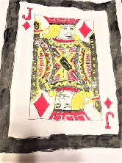
4 3
4 (four) jacks minus (-) 3 (three) jacks equals (-) _______.

