Look at the items in the pictures and write either the number or the word on how many are in each picture:

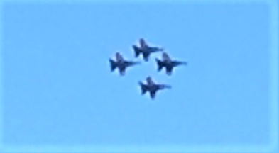

How many jets are there in the picture? ___________.

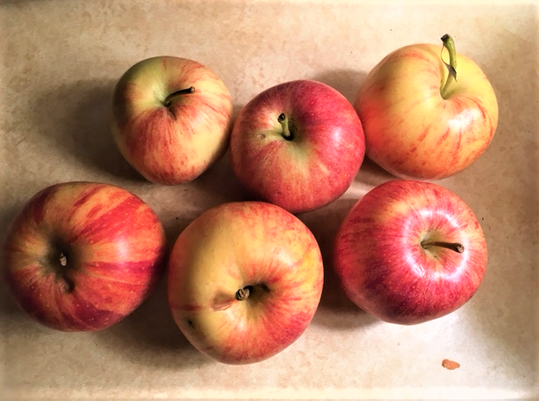
How many apples are there in this picture? _________.

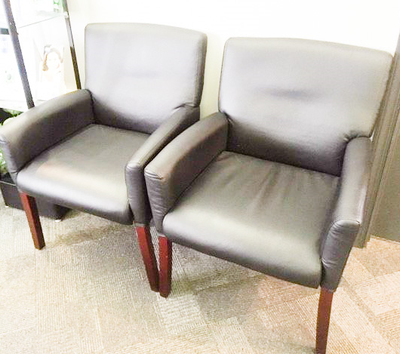
How many chairs are there in this picture? _________.

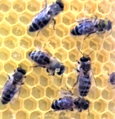
How many honeybees are there in this picture? ________.
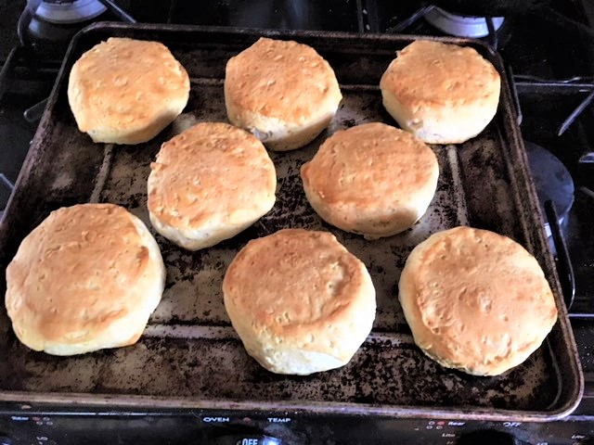
How many biscuits are there in this picture? __________.

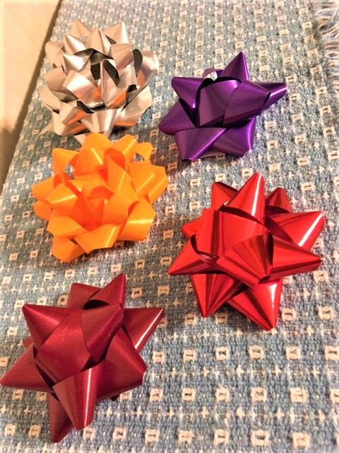
How many bows are there in this picture? ________.

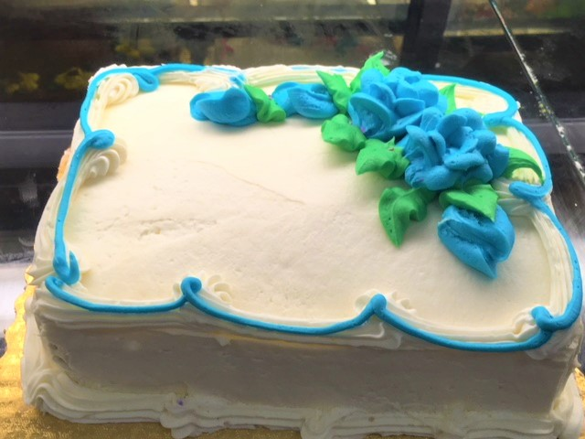
How many cakes are there in this picture? ____________.

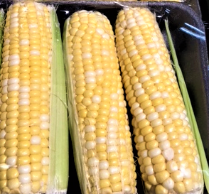
How many ears of corn are there in this picture? ___________.

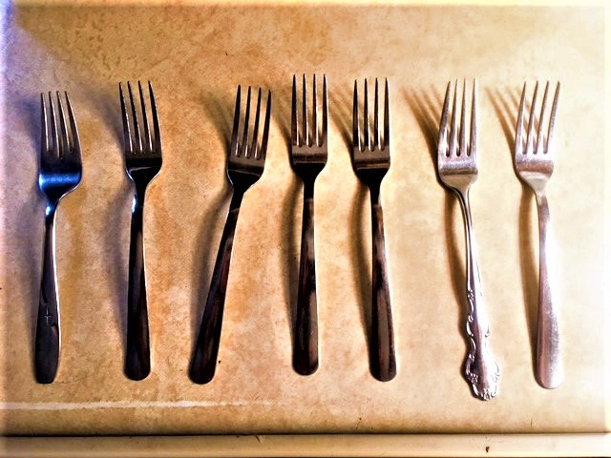
How many forks are there in this picture? ________.

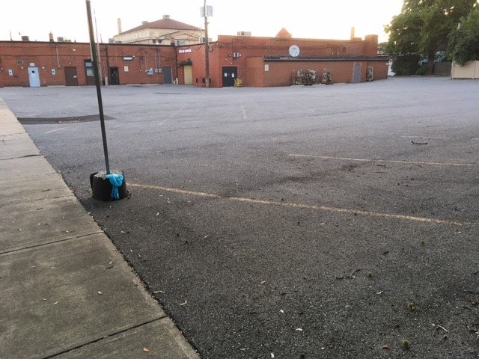
How many cars are there in this parking lot? ___________.

