Use a pen or a crayon or a pencil to color in the shapes the correct number listed below each set of shapes:

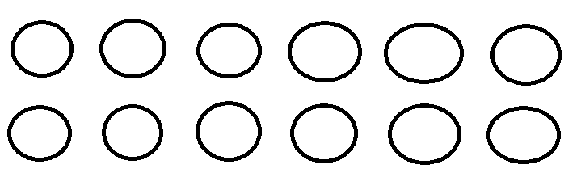
Fill in 5 (five) of the Circles above.

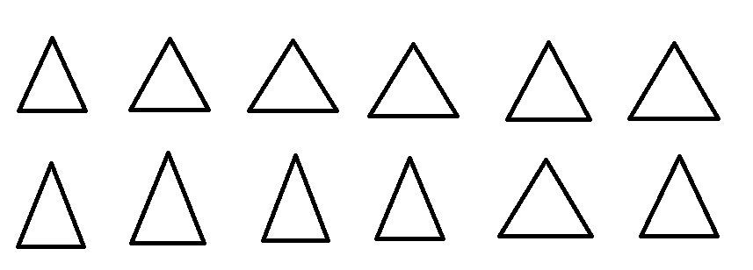
Fill in 7 (seven) of the Triangles above.
Fill in 8 (eight) of the stars above.

Fill in 4 (four) of the hearts above.

