Why Are
We Here?
By T .W. Gilbert
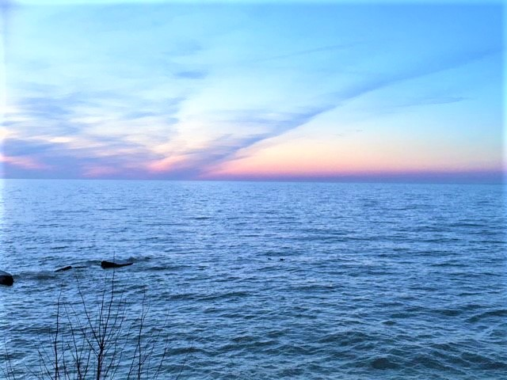
Why Are We Here?
By T. W. Gilbert
I’m not sure.
I guess a lot.
I have a lot of thoughts.
I have no answers.
This question has always bothered me.
I read a lot.
Sometimes I think I get it.
Sometimes I am just confused.
What is time?
What is space?
Are they limited?
Are they without limits?
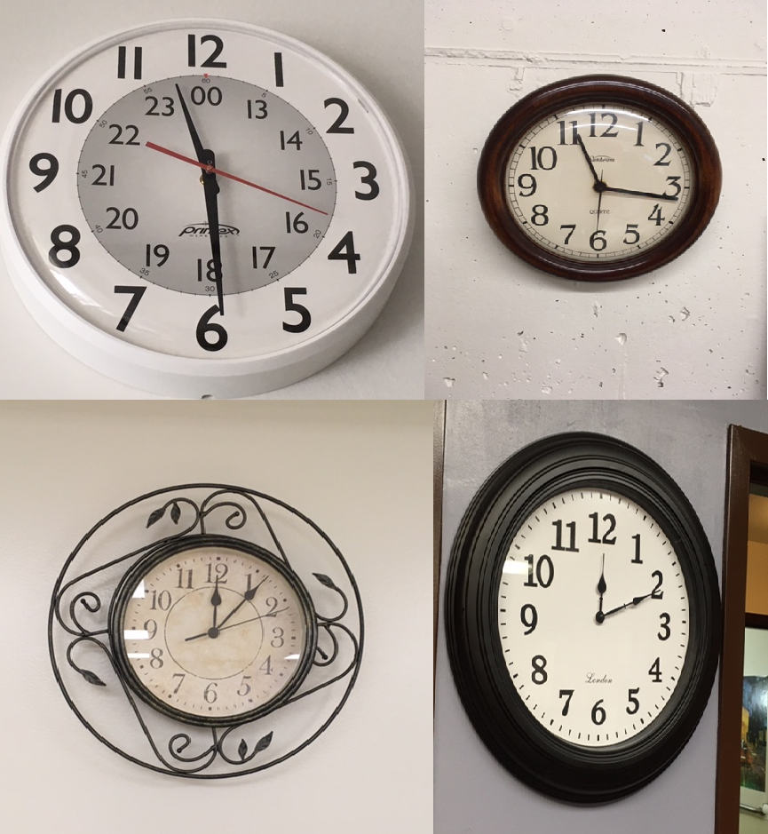
How did these things begin?
Did they begin?
Or have they always been?
Can these things be known?
If they can be known, what can we do to find out?
Is life somewhat like that old board game, “Snakes and Ladders?”
Or is it like Monopoly? Or Chess? Or Checkers? Or Tic Tac Toe? Or something else?
Is life something we should always be taking seriously?
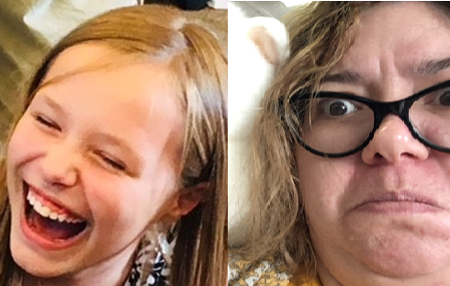
Or is it more like an amusement park or carnival, where we are supposed to have fun while enjoying ourselves?
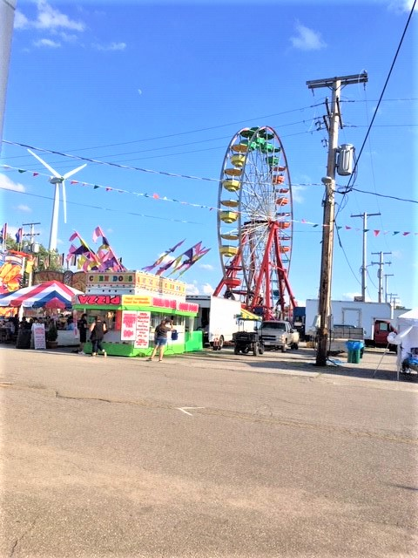
I don’t know.
I’m 71 years old now.
I think I know less now than I have ever thought I ever knew before.
Does that make sense?
I am interested in knowing everything.
I’ve always been very curious.
The world and the universe have too much to learn and know.
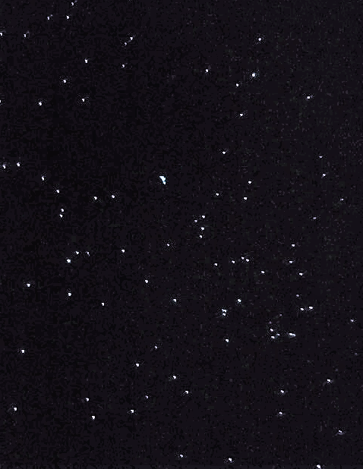
Just the other day, I was sitting quietly and thinking, and I realized that ½ minus 1/3 equals ½ times 1/3, or 1/6.
Then I also realized that 1/3 minus ¼ equals 1/3 times ¼, or 1/12.
The more I thought about it, the more I realized that it is a simple universal formula:
1/X minus 1/(X+1) = 1/X times 1/(X+1).
But there are literally thousands and thousands of simple and complex mathematical formulae that I have never seen and would not ever understand.
And that’s just the field of mathematics.
What I think I know is teeny tiny.
What I don’t know is freaking huge.
So how do I know what I know, even when it is very, very limited?
Just a few months ago I became aware that Blue Jays are members of the crow family.
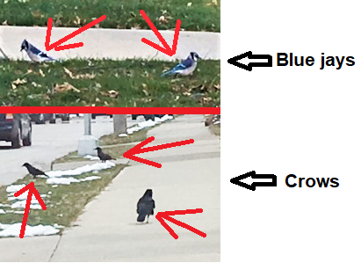
I had not known that.
It makes sense in a way because Blue Jays, like crows, are ruthless scavengers.
They both will steal young baby birds out of unguarded nests to eat.
What are good and evil really?
Who decides the lines between the two?
Are good and evil very separate things with a huge gulf between the two, like The Grand Canyon?
Or is there a very large gray area where it’s hard to decide which is which, like a fun house room full of mirrors?
I guess any suspected answers may determine why we have so many lawyers and courts and police and laws.
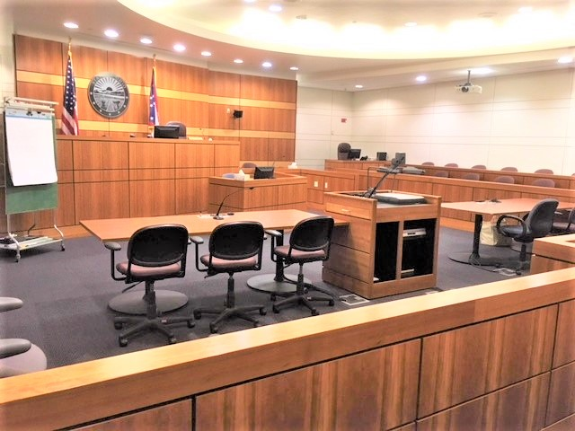
I feed the birds at my girlfriend’s (fiancé’s, love-of-my-life’s) house.
In the winter we get mourning doves, sparrows, tufted titmice, nut hatches, juncos, chickadees, blue jays, black birds, cardinals, the occasional robins, woodpeckers, flickers, squirrels, and deer.
In the summer we also get red winged black birds, finches, grackles, starlings (which have all migrated), and the rare blue bird.
Hawks will sometimes drop by to try to catch any of the birds for a meal.
All of the other birds and animals scatter when the hawks show up.
The birds and animals who come by regularly to feed do not seem to pay much attention to such questions as, “Why are we here?”
Maybe they already know and do not consider their knowing relevant.
Maybe they don’t care.
It might not be important.
Lunch may be a significantly greater priority.
Do you think the inventor of the game of Scrabble simply retired after creating that game?
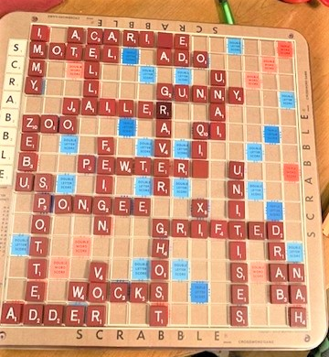
Did he go to live in a beach resort somewhere, living off the immense income he received from the perpetual sales of the game?
Or did he continue to think about other games to invent, other things to explore, or other professions to discover or entertain?
“Why do we work all our lives?” is as much of an unanswerable question as “Why are we here?”
And why do we choose the things that we do?
Do we have a choice regarding the things that we choose, or is it perhaps destiny at work?
Can we know which is true?
Did my field of work, my profession, choose me, or did I choose it?
I take long walks just about first thing every morning.
I think it keeps me healthy.
I used to run in the mornings.
I might get back to doing that again when springtime arrives, and sidewalks are clear of snow and ice.
Sometimes I plan my routines.
Sometimes my plans seem to have minds of their own.
They seem almost sentient, and part- time partners.
Sometimes they choose to get done.
Sometimes they choose not to get done.
I get up at 5:00 AM every day so I can start my days quietly and calmly.
I prefer to get my morning routines done so as not to rush.
I’m too old to be in a hurry.
My Muse always seems to be in a great hurry, though.
(My Muse is sort of like my guardian angel, I think.)
So, I’m deliberately not going to be in a hurry.
My Muse is a voiceless voice ‘that’ (may actually be a ‘who,’ I’m not sure.) has always been there to tell me things, my entire life.
She delights in sharing things when I’m sleeping, bathing, running, driving, eating, whatever.
Mostly when I’m too busy doing earthly or necessary things.
So, I have to keep pen and paper with me at all times (or at least now I have a charged cell phone so I can type into it on the note’s APP).
As I am somehow attuned or connected to my Muse, I get to be a writer of everything she shares.
So, I write a lot: things that come through from my Muse.
Here are a few examples:

1. “Is the spirit in beer like the spirit in man,
when a cold rigored body’s like an empty beer can?”
2. “I don’t believe there’s a yardstick that measures crazy.”
3. “Sometimes the most aggravating thing we can ever experience in life is day to day living.”
4. “Is painting oneself into a corner a learned skill or an innately presumed talent?”
Do we usually (or only) pay attention to the things in life that are comfortable to look at?
Our expected routines?
Are the things that we think about like the things that everyone thinks about?
Or are they the things we think everyone thinks about?
Yet we all slow down on the highway to stare at car wrecks and ambulances and firetrucks that are busy trying to fix things, clean up, and make the scene better or safer.
I’ve seen very few articles, or studies, or talks, or discussions on a thing called the “Host/Parasite Paradigm.”
It may be a very important, yet very uncomfortable, topic for discussion.
The foods that we all eat are sacrificed for our very survival.
We all eat to survive.
So, we are all basically parasites feeding off of hosts.
You see, it is an uncomfortable topic.

Haiku

“I don’t want to know
which side of the dilemma
I want to be on.”
Here we all are, basically, as necessary parasites, feasting on foods that keep us alive, and not ever really worrying about it.
Except when we worry as to whether or not we can even afford the foods we want when we go grocery shopping.
But cancer is also a parasite.
And tree fungi (the plural of fungus is not funguses, but fungi) are also parasites.
And Pileated woodpeckers are also parasites.
They will harvest just a certain small amount of ants or larvae off of a rotten dead tree stump.
They will leave the rest so they don’t endanger the ant colony too much.
They can return day after day to get more ants as food, just enough to eat without killing off the hive.
So, Pileated Woodpeckers are actually ant farmers.
Today, driving in to work, I heard an unusual story on NPR on the radio (yes, that was redundant).
It was about a marine biologist who accidently observed a pack of killer whales (orcas) attacking and killing a very much larger Blue Whale.
The blue whale is the largest mammal or animal living on our planet.
The scientist had not known that orcas could act as an organized pack to kill a blue whale for food.
I had not known it either.
I had known that people sometimes help endangered sea mammals when they get beached unexpectedly due to storms.
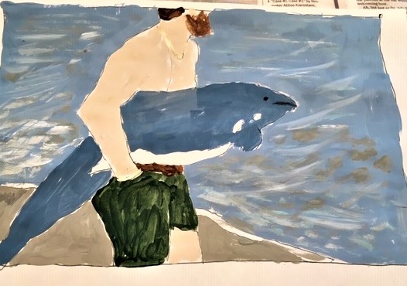
Life can be very strange at times.
‘Unknowns’ can become ‘knowns’ at any time, on any day.
Sometimes life is a puzzle.
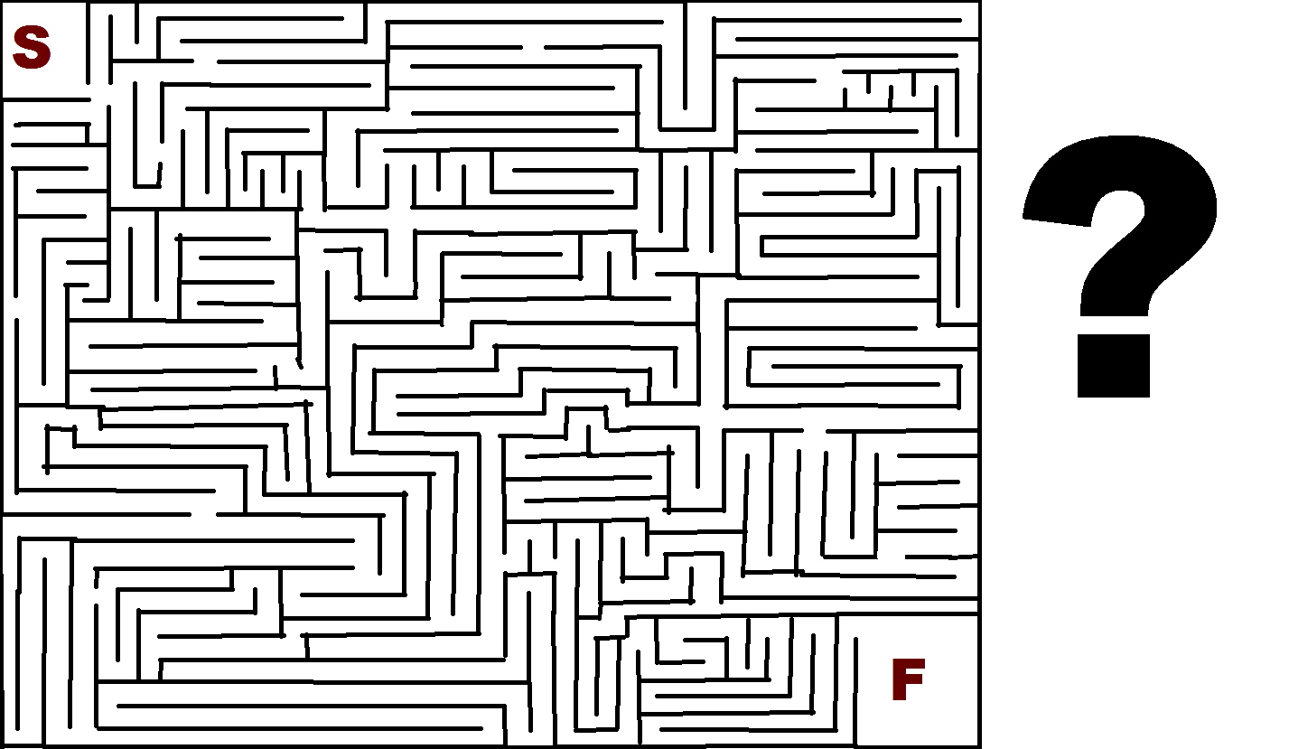
Sometimes it just needs much thinking and observation to figure it out.
Here is a puzzle.
See if you can figure it out.

Make a poem with the words:
“His, Sew, Our, Blew, Sour,
Her, Ewe, Read, Let’s, Shook,
Says, End, Rows, Vial, Suite, Hour.”

Use each word only once,
So the poem sounds just right.
If you find several answers,
you’ll need help with your plight.

(Answer somewhere in this book, but don’t peek.)
Is life challenging?
Is life a problem, or a series of problems, to be solved?
How do we know?
Are we supposed to know?
I wrote a poem about this a few years ago.
Actually, I’ve written a whole lot of poems about this very question.

I even have books of poetry written about this topic.

But this one specifically is one that best captures what I was trying to say, I think:

The Game

When is a test not a test but a wall,
and when is a wall not a wall but a
test? Does one have to choose what the prized all
important magic tortoise casts as the

fortunes of the day, coins or yarrow sticks
tossed like bones or stone runes, to know or guess
which paths or courses will cause the least mix
of pain, regret, despair? I spread my mess

around to fix a new perspective, place
cards in pet positions to chance a new
beginning, a fresh set of trends, embrace
a stance of will, fair, right, and true, a brew

from cauldrons stirred on moors, what Fate abhors,
when challenged for controls of terms and scores.

Does life have rules?
Yes, there are governmental rules (national, state, and local regulations), and there are of course religious guidelines.
And every business has rules.
But rules are always questioned by political parties currently not in control.
And there are as many religious interpretations of scriptural rules as there are people.
Who knows what’s right and wrong, what’s good and bad?
And we all have such a short amount of time to try to figure it all out, while we are here.
Do we have to figure it all out?
Does life end when we die?
What happens when we die?
Do we have souls?
If so, where do our souls go when we die?
Do our souls die, if we have them, when our bodies die?
Do dogs and cats and cows and goats and sheep and horses and fish have souls?
How about plants and trees and rocks and gems?
Are souls made up of energy or what?
Do things need souls in order to exist?
Do sentient and non-sentient creatures and things have souls or energy?
What holds a rock together as a rock?
Are thoughts and emotions forms of energy?
Can the thoughts and emotions that we feel and think be felt by others?
Can they be felt and thought by others at a distance, or over time?
Whenever I’m standing by the kitchen sink with my hands in the hot soapy water doing the dishes, I always start thinking about people in my near or distant past that I miss, or that I have had problems with, or that I have unresolved issues with.
Does that make sense?
Is that just an aspect of karma staring me in the face?
Does karma really work, or happen, or exist?
Is karma a universal balancing tool?
Is it an “every action reserves a space and time for an equal and opposite reaction, a balancing of polar opposites?”
If karma is a universal balancing tool, why is it even necessary, in a world where nothing seems really predictable?
Do you know what is going to happen tomorrow?
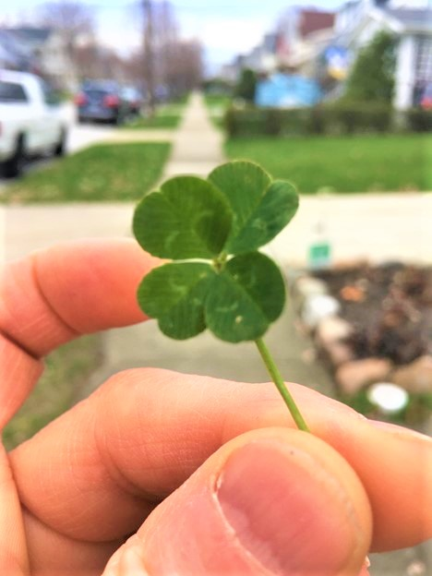
I don’t.
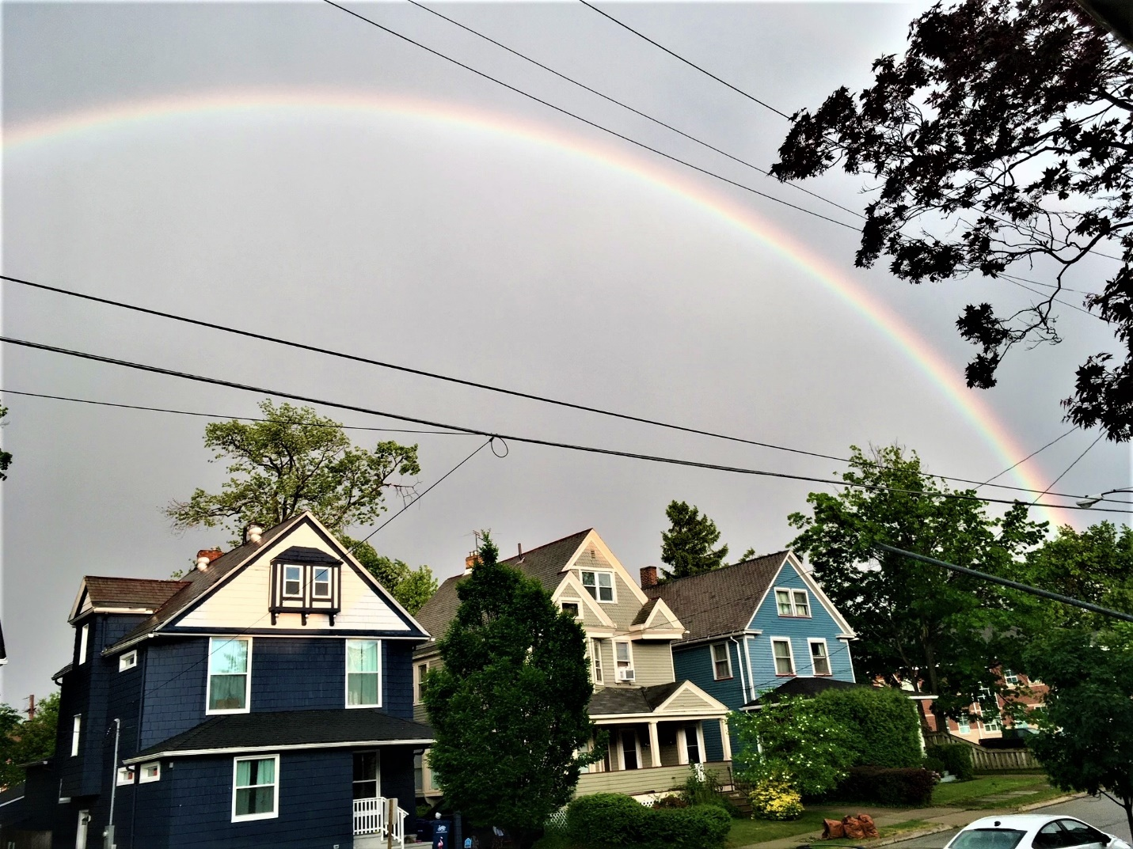

Are all of the libraries in the world simply filled with millions of books by authors who were just trying to figure it all out?

And now think of the millions and millions of books that were written but never ever got published.
(I’m sorry, I didn’t mean to give you a headache.)
speculation
[ˌspekyəˈlāSH(ə)n]
NOUN
- the forming of a theory or conjecture without firm evidence.
"there has been widespread speculation that he plans to quit" ·
[more]
synonyms:
conjecture · theorizing · hypothesizing · supposition · guesswork · talk ·
[more]
- investment in stocks, property, or other ventures in the hope of gain but with the risk of loss.
(the above borrowed from Microsoft Bing definitions)
A Pessimist’s lament

We come here lost to share some love when what
we find is strange. If we could see all points
and ends we might try hard to change. The rut
we trudge in daily steps is what anoints

our dreams. We fail to ever figure out
that life’s not what it seems. We cannot hope
to ever learn or see what we’re about.
We speak and think and listen hard and cope

with every doubt. But reaching with our yearn-
ing just to hold another soul, and touch
a glimpse of “otherhood” to help us earn
what’s whole: is everything, and more, as such,

a blessing that we need, a flow of bleed-
ing light from hearts that wish just to be freed.

A couple of years ago, I came up with a saying (probably handed to me by my Muse).
I think it holds true for the most part.
“People help people; businesses, companies, corporations, and governments can’t and won’t.”
And then there’s simply everyday life that we put up with and try to do our very best at.
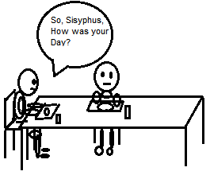
What motivates artists to paint pictures and composers to compose music?

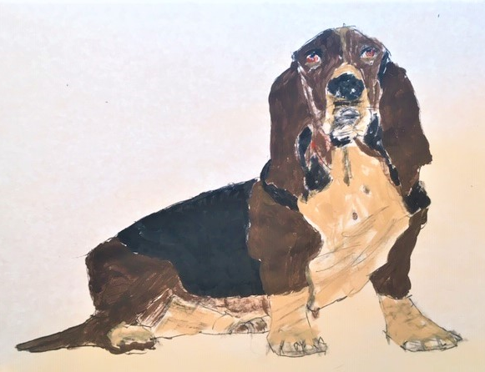

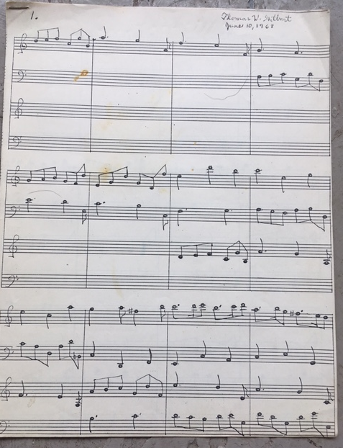

Is it the same for writers who write novels and poems and short stories?
Is it almost always a life of prolonged pain and anguish that provides the backdrop for creativity?
Why is there so much pain and hurt in the world?
And why is there so much loss and grief?
I often try to figure out why all
of us are here. There may not be a bet-
ter time to state what isn’t clear. Last fall
my wife received some news: her cancer’s set
her time. The price of guessing what to do
came like a sidewalk dime. I pick my nose;
I pull my beard; I stare at nothing new.
The TV off and books unread now close
her life that’s through. The weighing and the meas-uring aren’t like a game of fish. We can
not go, nor ask for cards, nor make a treas-
used wish. The visiting will be our plan,

like tea times filled with treats, where sugared eats

for featured guests will follow what retreats.

(My late wife, Deborah, passed on June sixth, 2017.

I then met Emma in September 11th, 2018.)

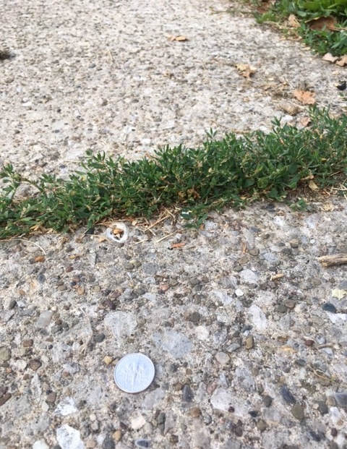

Are these conditions explainable?
Love and joy and happiness seem to be so fleeting.
And memories are an over-explored garage sale.
And sadness seems to be so much like this rainy day:
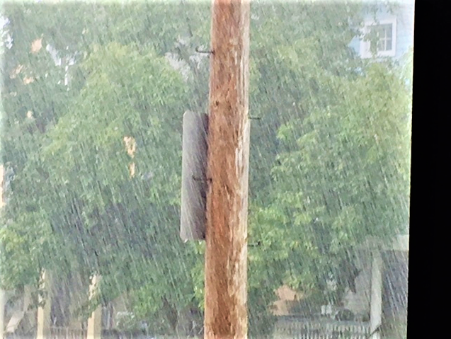
And society seems so much like this swarm:
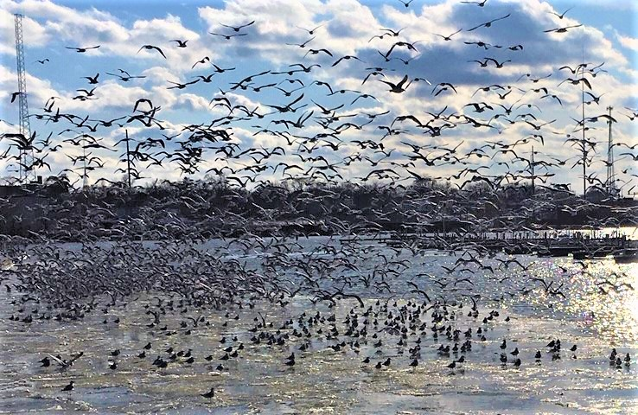
I think I need a little of this:
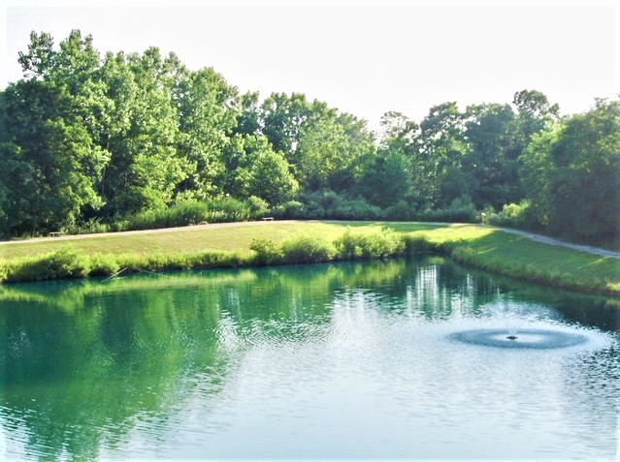
And a whole lot of this:
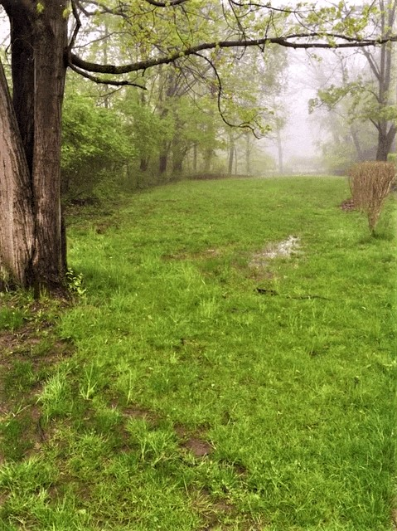
And some of this:
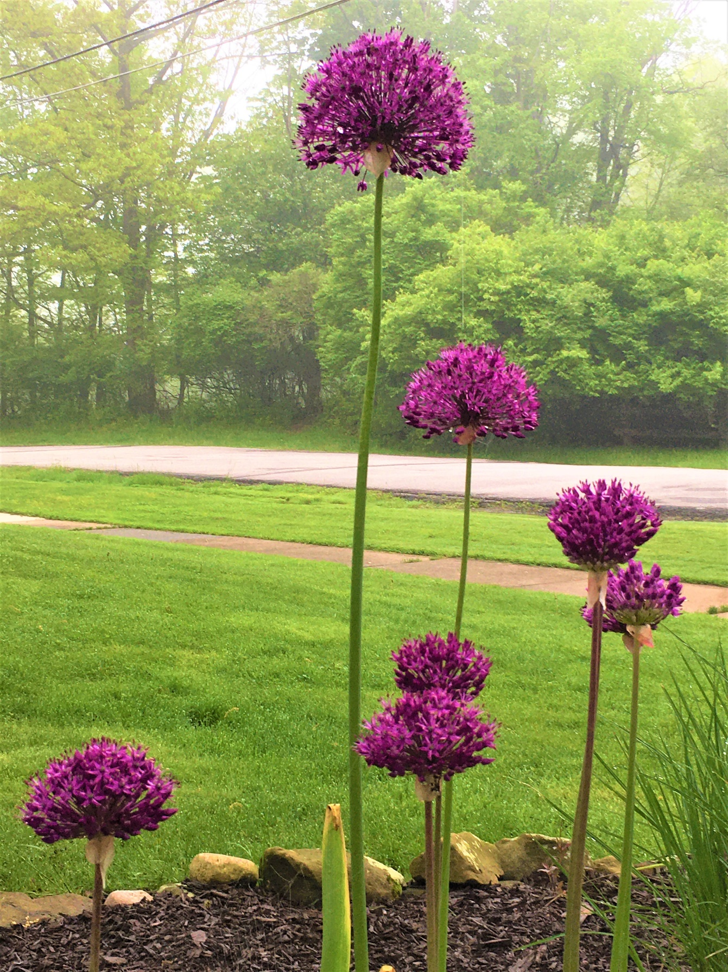
During this last year, my old car, which has now gone almost 140 thousand miles, blew out all four of my old tires, one after another.
At different times.
Each one happened while driving on a highway.
Both front tires and both rear tires.
And each one of the blowouts was split right along the sidewalls near the rims.
And all the rips were about 16 inches long.
What are the odds of that happening?
Ya gotta laugh, maybe.
I’ve retired from working now twice, and come back to work twice.
I’d really like to buy a small farm and raise organic veggies to can and freeze.

I bake my own homemade bread.
I’ve been doing it for over 50 years.

I tune my own piano.

I taught myself to do it over 30 years ago.

I realized I could do anything I set my mind to years ago when I organized a senior league ice hockey team and we played for several years in an ice hockey senior league. It was a lot of fun. The members were any age over high school.
Folks around me told me I was crazy to do it.

I did it anyway and it worked.

Sometimes crazy is the way to get things done.
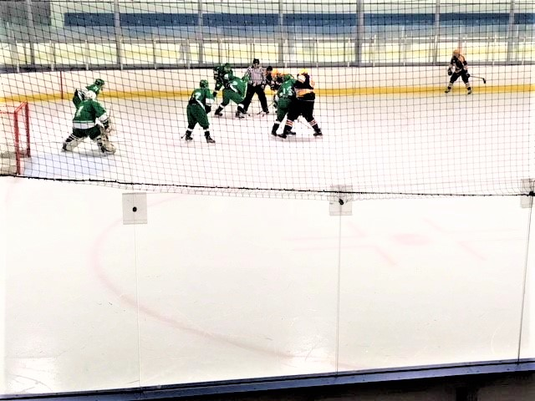
Are difficulties that we encounter in life the very warp and weft and fabric of existence?
Like the necessary pieces in life’s puzzle?
Like stop signs?
Like pot holes?
Like wrong numbers?
Like the flu?
Like pink slips?
Like tooth aches?
Like family arguments?
Like hang nails?
Like ice storms?
Like broken can openers?
Like litter?
Like broken shoe laces?
Like death?
Is the whole of existence a marvelous perfection?
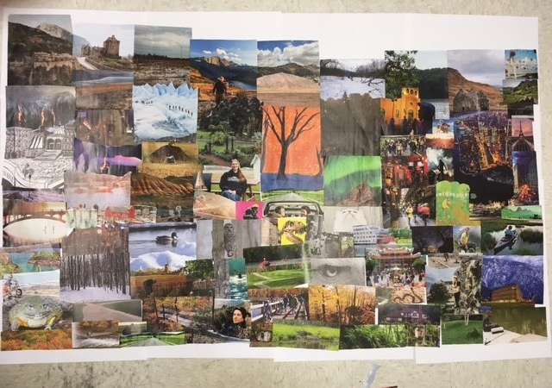

Even if it’s a balance of purposeful chaos and unimaginable joy?

Neighborhood Watch

I want to protect reality,
but I don’t know
where to get
the fenceposts.
I work at a facility that takes care of individuals with intellectual and developmental disabilities.
I’ve been doing this kind of work for 52 years.

One of my jobs is to read to 4 of the various groups of people at the day program that the company operates.

Most of the people who are listening to me read each week are non-verbal or only slightly verbal.

I’ve read them short stories, some things that I’ve written, and even Charlotte’s Web by E. B. White.
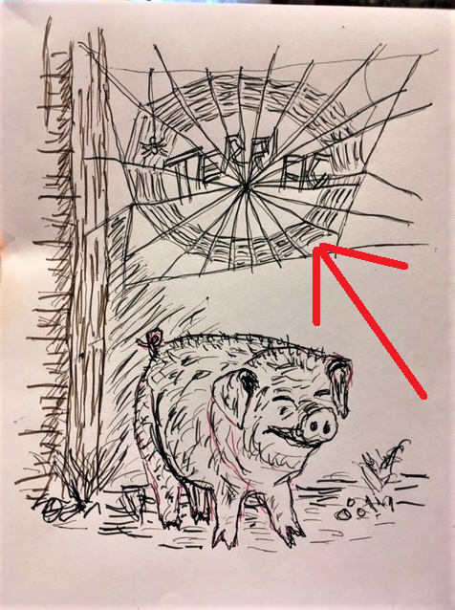

I’m currently reading The Lord of the Rings by J. R. R. Tolkien.
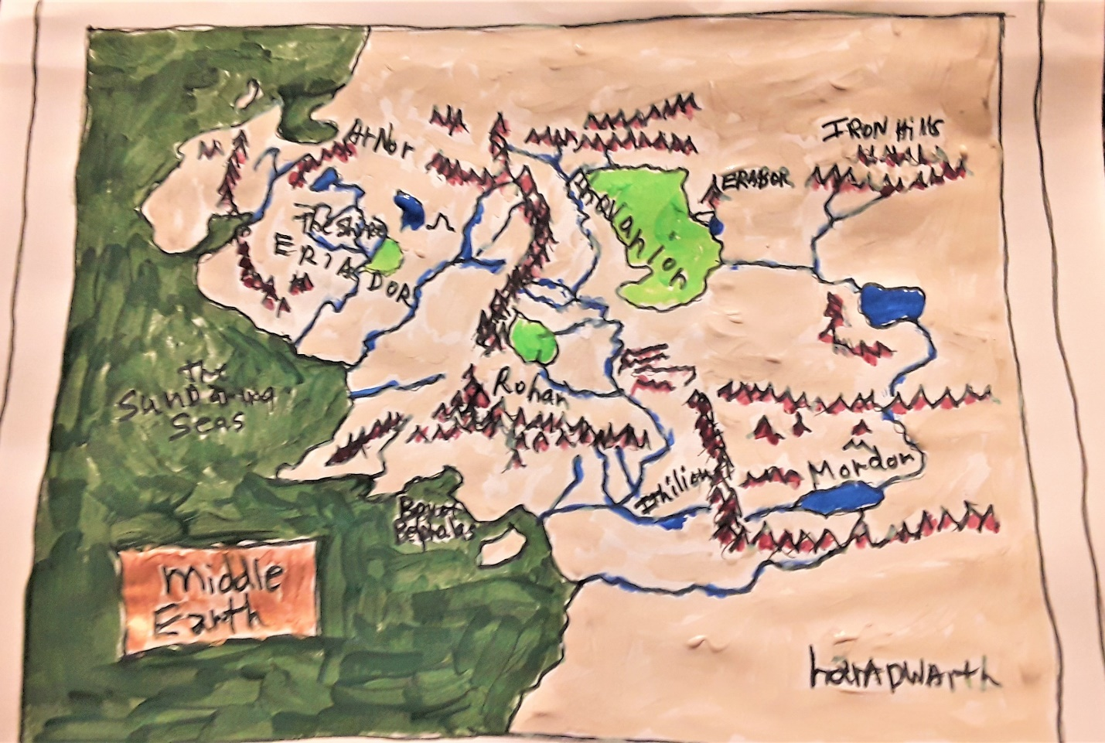

What is fantastic about this process, is that, every once in a while, I take a pause to catch my breath.

And I’m immediately aware of the absolute silence in the room as I’m reading.

They are all paying attention to the story.

This happens every week that I read.

I read for a half hour every time I read, once a week for each group.

I need no other confirmation of how really good this really is.

Say the following words out loud:

RED GREEN BLUE

PURPLE YELLOW BROWN

PINK ORANGE BLACK

What do we see?
What do we know?

What do we assume?

What are abilities?

What are disabilities?

What are capabilities?

How do we learn?

What can we experience?

What effects how we think?

Are we aware of those things that effect how we think?

Rows says sour read,
Vial let’s our blew,
Shook her his suite,
End Sew hour ewe.

Does what we think and see and know and learn depend on what we may be totally unaware of?

How much of what we think and see and know and learn effects those we are in daily contact with?

How much of what we think and see and know and learn effects those we care for?

How careful are we of others and their own abilities to think and see and know and learn?
Autism (oughtism, as opposed to noughtism)
Father says,
“I can put on my socks
and my shoes
and I can lace them
and tie them.
Can you?”

Child thinks,
Wednesday
smells like cinnamon.
The rain is a pink
red sound and
makes the swirlies
in the air
spin backwards,
but slowly.
Nature says,
“The oak trees
make big acorns
for the squirrels,
and sing when the squirrels
scamper to get them.”
The maple trees also add,
“We make syrup for pancakes,
why don’t you?”

Mother says,
“It is time
to empty
the dishwasher.
The plates
and the cups
go up here.
The spatulas
and the ladles
go there, and
the spoons,
knives, and forks
go in this drawer
in these compartments.
Can you
help me
do this task?”

Child thinks,
But why is
the number ‘15’ orange?
And the number ‘4’ red
and the number ‘7’
a shimmering green?

Nature says,
“Pond sits still
all day
for the fish
and the ducks
and the frogs
and asks,
‘Can you do that?’
River flows always
on and on
for the boats
and the fish
and the land-cleaning
and the land-feeding
and asks, ‘Can you do that?’
Rain jumps
from the clouds
all the way
to the ground
for the crops
and the plants
and the trees
and asks, ‘Can you do that?’ ”

Teacher says,
“Now children,
please take off
your coats and hang
them up, then
slowly and quietly
walk to your desks,
and let’s get ready
for morning routine.”

Child thinks,
It’s as if the taste
of water
is more like
the number ‘10’
than the number ‘1’,
because
the number ‘1’ is
really white,
and the number ‘10’
is almost clear.

Nature says,
“ ‘Ought’ is a zero
which is black
and is nothing,
but ‘ought’ is also
a circle, which is
everything and sky blue,
or maybe
it is both
nothing and everything,
or maybe neither
nothing and everything.
But it’s also
love and kisses and love and kisses…”

Father says,
“It is time to go
outside and rake
all the leaves and
put them all in even piles
and spread the blankets out
to put the leaves in
and then carry them
out back
to compost them
by the garden.
Here we go.”

Child thinks
When I look up,
through the morning hours,
to lunch time,
I’m not sure I can
get there from breakfast,
but when I’m at lunch,
dinner seems
not so high
or so low,
but just way over
there somewhere
in the distance;
but at suppertime,
looking back at the
chasm of the day,
it wasn’t so bad
a lengthy trip,
but then again,
tomorrow morning looks
like both the end
and the beginning
of the ride,
which we do
again and again and again.
But there’s this weird
tunnel we have to go
through to get
back to morning.

Nature silently
teaches silence
through all the senses
that sense
what she’s doing.

Mother says,
“It’s time
to go
grocery shopping.”

Child thinks,
Get-your-coat-
get-your-shoes-
get-your-hat. But
grocery store is
28 symphonies
all playing at once, and
grocery store smells
too, too much
for one place,
and florescent lights
make continual
jack hammer noise,
and car ride
tastes like soap,
and wind is a dark green,
and song on the radio
looks like stale popcorn
and smells like toothpaste,
but car seat
feels like a prayer.

Mother asks,
“Would you rather
we go to McDonalds?”

Child thinks,
It’s not Tuesday.
We can’t
do that today.

Are the days that we live each day just like individual pictures in a nickelodeon cartoon that flicker, in passing, like sun light through leaves on a tree?

Or are they more like soap bubbles blown from a child’s bubble pipe that float for a bit in the air in rainbow colors before popping and disappearing?

Why is it that when eating a salad always the last few pieces in the bottom of the bowl will be pieces of celery and shredded bits of carrots?

Which is funnier: Being seriously humorless or being humorlessly serious?

Do privileged and upper-class fleas have gated communities in the best real estate areas of a dog?

When “being led down the rosy path” leads to certain uncertainty, will you know that you have arrived?

Is the truth about life perhaps not only unrevealable, but also undiscoverable?

Is self-discovery like cracking an egg to examine the shell?

Is there no sadness like today, no regret like yesterday, and no fear like tomorrow?

Do tobacco shops ever sell healthy organic tobacco?
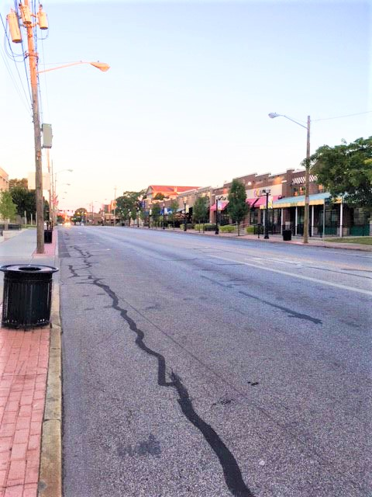
Is the world a poem with millions and millions of authors?
Each laying down a verse or two, rhymed and unrhymed?
Sensible and nonsensical?
With insight, and foresight, and hindsight?
With as many joys as there are warnings?
With as many shouts as whispers?
With as many wake ups, as tucked ins?
With as many welcomes as go aways?
With as many screams as smiles?
With as many punches as touches?
With as many answers as questions?

“Oh, a bull frog sittin' on a railroad track
Singin’ Polly wolly doodle all the day
just a pickin' his teeth with a carpet tack
singin’ Polly wolly doodle all the day
Fare thee well, fare thee well,
fare thee well my Froggy Friend
goin’ to Lou'siana for to see my Susyanna
singin’ Polly wolly doodle all the day”*
[repeat as often as seems necessary]

Thank you, dear Reader, for supplying the necessary thoughts and feelings which comprise the words on these pages, for without them this book would be entirely blank pages.
T.W. Gilbert

