God Doesn’t Always Gently Hit Us Over the Head:
By T. W. Gilbert

God Doesn’t Always Gently Hit Us Over the Head:

All wars are simply seasonal and kind-
er than cold spring; life’s warp and weft have war
which has deep roots of fabriced string, that bind
our wondrous Earth in places blessed for scor-

ing schemes, those held in high regard by all
who worship righteous dreams; we march in time
to drums and flutes for those who got the call,
that message stating duties are sublime

lest freedoms fall. There is no greater glor-
y than the slaughter of our foes, for now
we know our God has blessed us, it’s how war-
ring goes. Necessity is always how

we laud those who have served, with fame preserved
for all who fought, while peace stays unobserved.

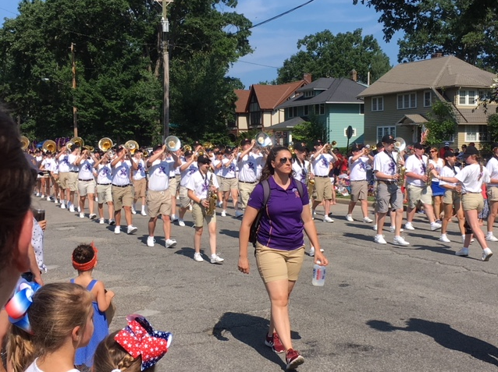

Money and war go hand in hand, they’re wed-
ded at the hip. When fiends can’t see immor-
tal souls in all, then here’s their trip: Instead
of being kind and generous they choose war

not peace. Advantage with all cards they play,
where conflicts never cease, provides them ben-
efits, not loss, while losers fear dismay.
Equality is never shared, but then

what should they say? “It’s dog eat dog,” or “life’s
a bitch,” “survival is what’s real.” One can’t
address all troubles in this world where strife’s
the deal: No patience shared where love is scant,

no giving as one steals; so many deals
that war provides while greasing pocket’s wheels.

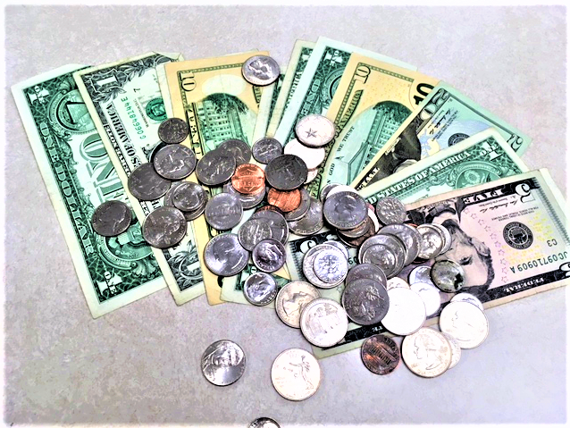

The risk of loss is fine print news as war
is glory filled, while propaganda’s flag-
waving is bombs and rockets skilled. The score
of caskets from both sides, a tail to wag

the dog, is left for those who count statis-
tics, not tear’s epilogue. The folded cloths
bestowed to mothers with a general’s kiss,
are clearly payments paid in full, while swaths
(Death’s scythe) share this. The music for war’s eu-
logy stays playing for an age, without
an ending, plus a coda: it’s the grue-
some wage. Life’s temporary, there’s no doubt.

So war just offers this: a chance to miss
death’s random mess by choosing Glory’s bliss.

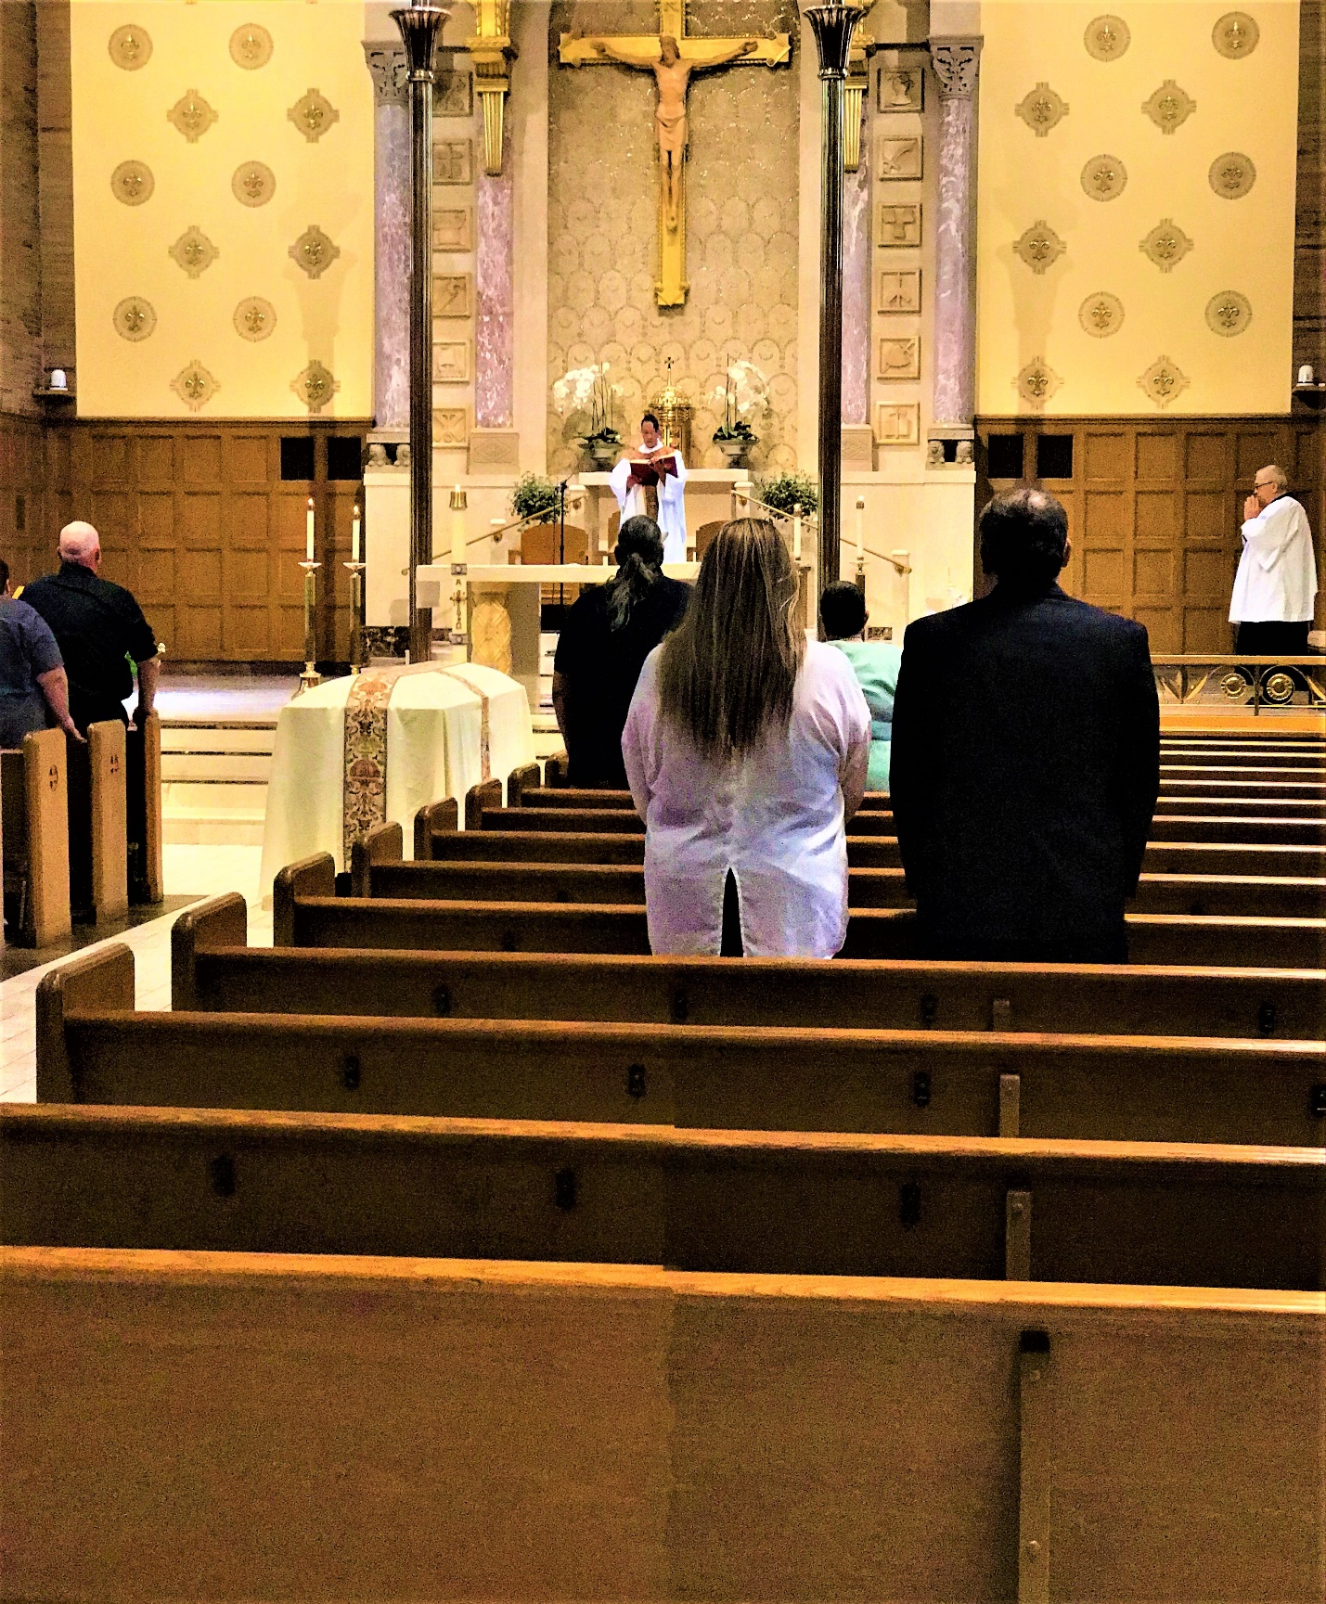

The recompense from war’s designs are strang-
er than what’s taught. Those compensations bor-
der on ideals that we have sought. The range
of goods both bought and sold were never war-

ring’s hopes: just freedom, peace, tranquility
were guaranteed as ropes, to be tossed out
to struggling hands, when rescued from debris,
while underground exchange of lands, no doubt

we’d never see. The news in hands of var-
mints always trains those who should know, the dif-
ference between the lies flung high and far
below. There’s never any sense to sniff

out truths that warrings quash, like “Oh, my gosh,
war’s terrible; but peace is just hogwash.”

Are wars just based on family dysfunc-
tion we know well? The hate and jealousy
that places blame at home in Hell? “You punk,
you little weasel, it’s all mine, just see

my point. You’re wrong, so quit your shouting, now,
you’re getting out of joint. Let go of what’s
my property, you sniveling beastly cow,
you have no leg to stand on, as you’re nuts,

I’ll show you how! I bought these things from change
I stole from out of mother’s purse, last Sat-
urday when mom and dad screamed words that strang-
ers curse; she never saw his rage, that bat

held high above her head, his eyes were red
like mine right now; I wish you, too, were dead.”

Unwelcome are all things of war, but swear-
ing fits its niche. Complaints of war’s insan-
ity are cause enough to bitch. The wear-
ing down of morals helps all victims man-

age fear, with words screamed out to challenge those
shit fuck sick bastards here. All soldiers can’t
lash out at those in politician’s clothes,
who work for business interests that grant
where money flows. The grunts in trenches caked
in mud all dying for a cause, can on-
ly swear as bullets fly, while seeking faked
applause, that only they can hear as blown

grenades take life and limb, which makes Hell’s hymn
of words and death their peace as eyes grow dim.

When linguistic equivalents get mixed up:

War— wear, we’re, ware, were, wire, wore, where, worrier, worry, wary, weary, whore, here, hair, hear, hire, her, Hera, Hurrah, horror, hour, our, aura, har, har, har.

Swear—sari, sorry, seer, sere, sear, sayer, sewer, suer, sore, soar, sire, sir, S-wear (snake shed skin wear), sheer, share, shore, sure, shire, shower, sawyer, saver, sever, swore

Resources that we buy or steal are deals
that we pursue. Diplomacy or cash
loans may be needed to accrue, what feels
like raw advantage in this world where stash

is king. But means are not considered where
all laws don’t mean a thing. But if perchance
our efforts to obtain goods “fair and square,”
are hindered by events where no finance

will deals prepare, we can and do resort
to wars and coups to fix what’s right. The world
does not own us; we own the world through court
and might. We stand apart from what’s been twirled

in stories in the news. Let’s not confuse our freedoms with your laws of don’ts and dos.

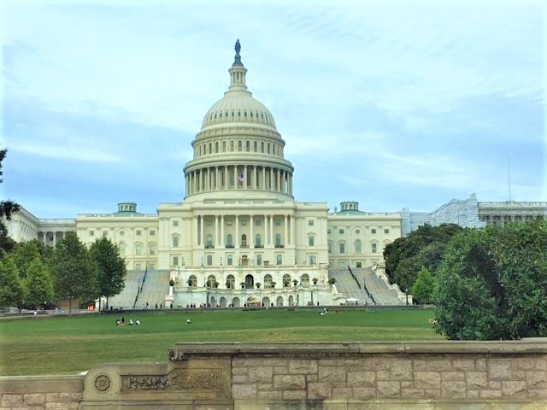

Our military might is backed by busi-
ness fiends within, the corporate-laden land-
scape that has bedded down with sin. There is
no bigger target than the trillions hand-

ed out to lobbyists who foster deals
for wars with business clout. The backroom trades
here and abroad are what “black ops” conceals.
They won’t relinquish secrets of their raids

to Time’s newsreels. Their underhanded threats
are linked to drones with cross-haired sights. The stor-
ies in the news will never bring assets
to lights. What we find out can kill us more

than ignorance can do. So, follow through
with staying here: I’m deaf and blind. Are you?

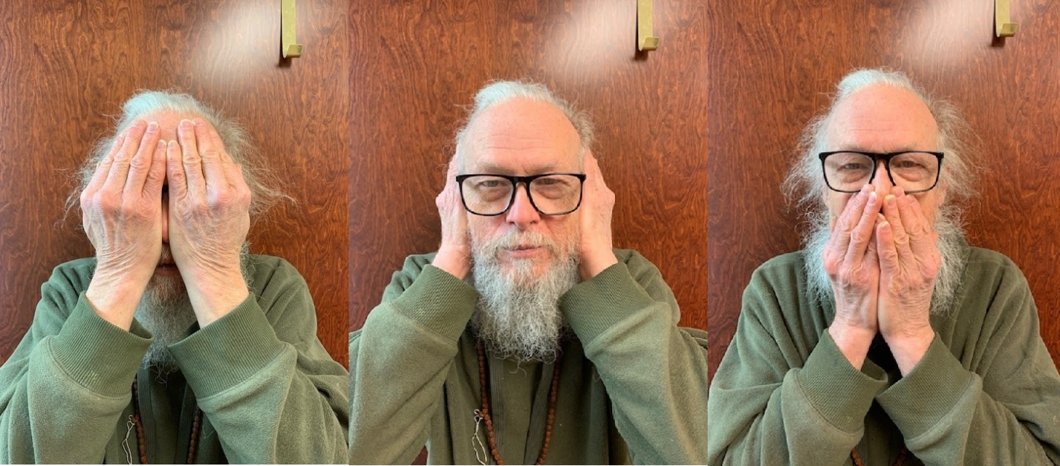

Compete or just cooperate, what means
do we pursue? It may depend on plan-
etary trines and squares in queue. Ravines
of opposition bridge no words that span

distrust. Advantages, short term, long term,
don’t settle what’s unjust. It’s like road rage
when traffic’s bad, remarks that make us squirm,
those unpaid bills, and debt that kills, when wag-

es reaffirm, that business rarely en-
tertains where charity makes good. So all
of us respond in kind, where no inten-
tion should. And war is just a business call,

a strategy of need, where wall street’s greed
is always good and handouts a misdeed.

Do trees complain of war’s misdeeds? Do we
have ears to hear? What means have they to reg-
ister their thoughts on rock and spear? What’s free
to go on two legs always wants to dredge

up war? Is war a sane profession, where
all others we ignore? The negatives
outweigh the positives you’d surely swear.
But billionaires know ways to cheat with sieves

to steal their share. There’s no way to defend
all wars yet somehow they persist. All bets
are off that they can end, so we’ll pretend
they’re missed. But we will never end all debts

that wondrous wars provide, where lives have died
a million times on every freaking side.

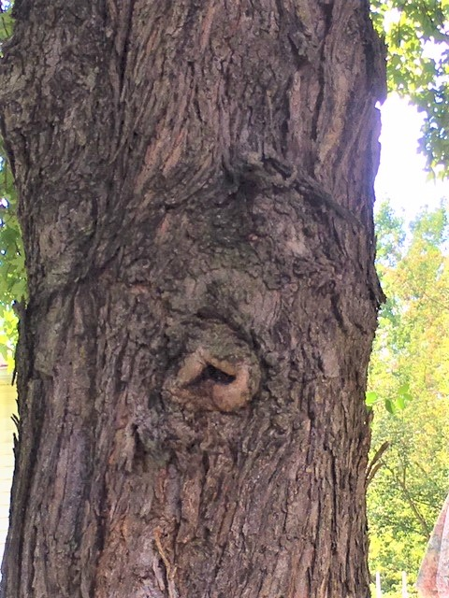
Imagination, memory, real-
ity, what’s true? Just never mind the quan-
tum realm, its truths are so taboo. Locale
in space and time and war is always gone

too soon, where lives and homes and restaurants
are floating to the moon. All bombs and rock-
ets rearrange all landscape’s friendly jaunts,
while making room for graveyards for the shock

of vaporous haunts. We’ll never lose excus-
es for our willingness to kill. We’ve mill-
ions of examples on how just to use
that skill. Abomination’s normal will

you not concede this point? God can’t anoint
our grieving souls while war holds our viewpoint.

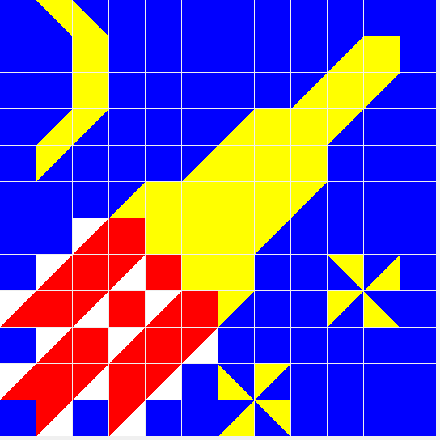

When wars inhabit springtime it’s like flow-
ers praise the dead. They come and go so quick-
ly we should wonder how they’re spread. Just how
the seeds of both are germinated sick-

ly fast, just shows how Mother Nature spreads
her needs with pressures massed. Killing, seeding,
fertilizing, life starts and ends in beds.
The marching, shooting, weeding are the sting

of common threads. What lives and doesn’t share
a fate of life and death and farm. We can’t
conclude we know for sure what guides this car-
ing harm. Survival means we bless each plant

and soldier we allow, to praise the plow
which does its work and grants a life somehow.

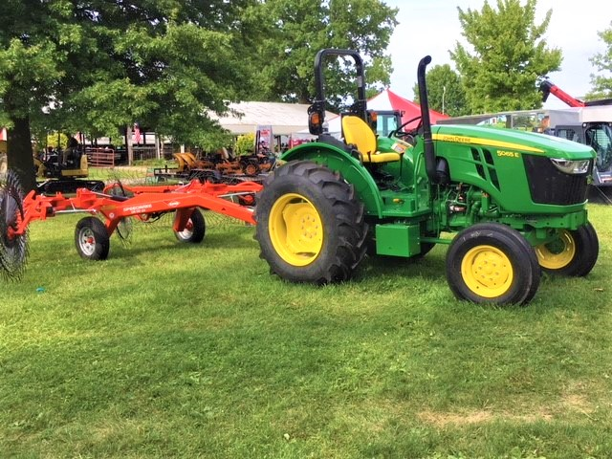

Sugar coated wrapping paper, let’s gift
wrap all that’s war, where all gave some and some
gave all, the few, the proud and more. So lift
the banners high my dears so all can come

along. We’re faithful in adversity,
duty first, army strong, firepower
for land power, be all that you can be.
A global force for good, get some, cower-

ing’s never free. Any time any place,
he who has planted will preserve. In peace
and war, make peace or die, just win the race
and serve. We know that wars will never cease,

we know they fit down here. But grinding cheer
for flesh and bones, may never make war clear.

War is just a doorway that is wider
than all of space, a place of soul dispos-
al that is marked with Heaven’s grace: bider
every age just waiting for all suppos-

éd gents, who willingly dispense with life,
in search of glory’s fence, that gated soul
community beyond all fears and strife,
a place unknown to earth bounds, but a goal

blessed more than wife, a monumental des-
tiny that cries out for those lost, a place
of harps and peace and love with blesséd Jes-
us crossed, where promises of God’s embrace

still welcome all who kill: presumed goodwill
for those who fought and died in Christ’s gristmill.

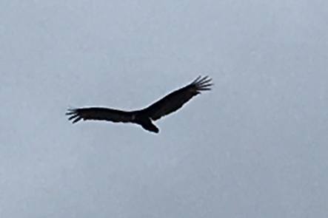

War’s scripts are laid out in advance, Hell’s mer-
cies are foretold, where heroes and their ev-
il twins embattle in the cold. The blur
of dusty aged texts that almost nev-

er fail at being cryptic, hard to fig-
ure, leave a gruesome trail, of severed limbs,
and bodies strewn upon this earthly dig.
The trail of evil’s sentiments are hymns

from Dante’s brig. There never was a hol-
y war, a merciful exchange, a peace-
enriched encounter where all worked for whole-
some change. Not ever was there such caprice,

a loving gentle mood. War’s ever viewed
as slaughterville; it’s always left us screwed.

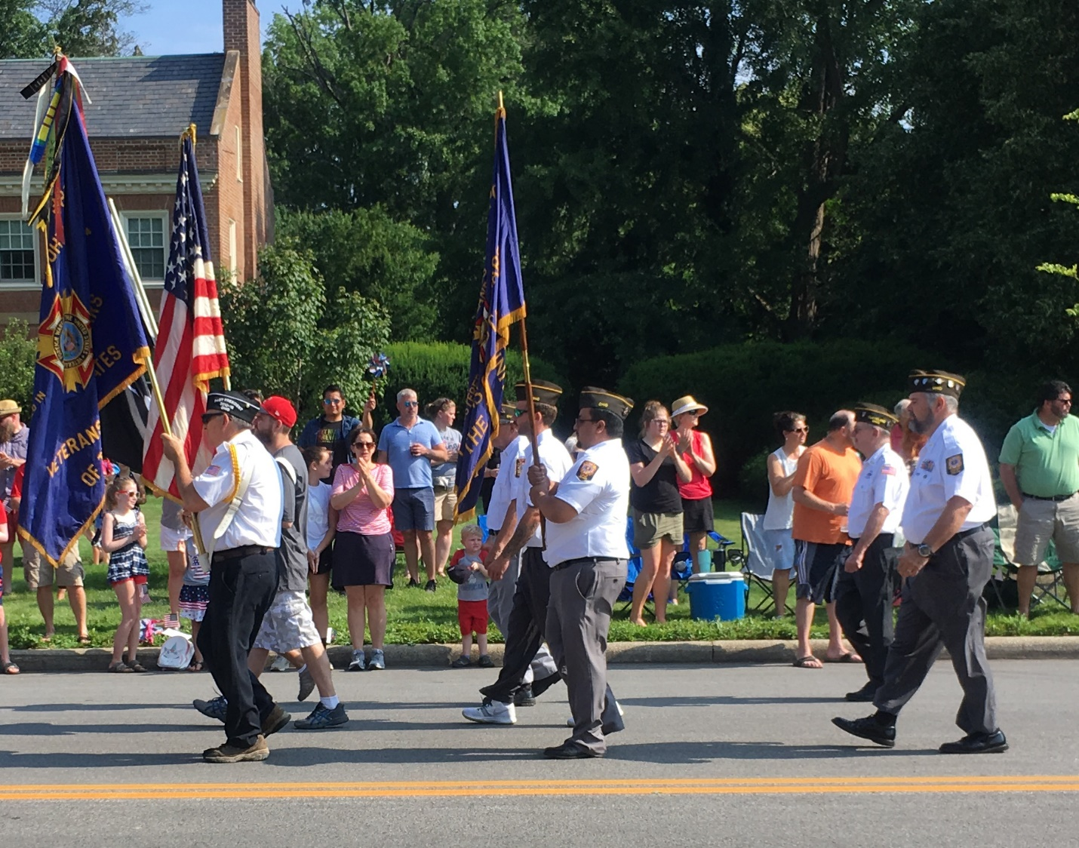

War’s just a bowling reset with pins flat
upon the lane. It’s nothing more than start-
ing over, washing clean with rain. A cat
with more than nine lives is like war that’s smart-

ly shrewd, it knows that all relationships
can bust up with a feud, emotions run-
ning high with misinterpretation slips, advantages and bandages with gun

on holstered hips. And war like Cheshire cat
that ever smiles at Hell’s plight, assures
all maimed participants who caused that spat
and fight, recycles soldiers for its tours,

and reloads men like knives, and best connives
to squander peace exchanging death for lives.

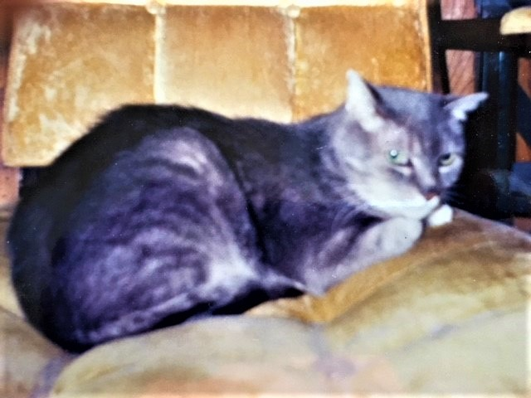

War has been religion’s lover, a sales-
man on the run, and State just looks side’s crab-
by way when bed that’s made’s undone. Details
of these relationships are front page tab-

loid news, while court attendants, jesters all,
are quick to hide the shoes. Beliefs and faiths,
in lurid masks, attend their midnight ball,
while secret allegations, plans, as wraiths,

get set to brawl. Donation plates passed down
the pews, some filled with gold and jewels, remind
the wholesale nobles who’s elite, or gown,
or fools. Position holds all fates aligned,

while war’s that game of chance, a dicey dance
where betters play for money, fame, romance.

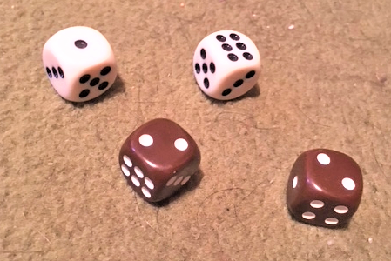

What can we add to words like war? There’s “warn”
with letters soft. Then “wary” that’s somewhat
like “warn,” but seldom held aloft. What’s born
in word-play sets a tuning, though it’s but

a theme, like “warp” a simple rug-like thread,
or twisted mangled scheme. Then “warg” is a
ferocious wolf that conjures fears and dread,
when ridden oft by goblin servants: the

fiends Sauron bred. Then “Wart” is Arthur’s nick-
name or a growth upon your skin. And “Ward”
is Beaver’s father or a spell to trick
your kin. But “warm” is never hot, good Lord;

for cold is war that’s crazed. With war that’s praised,
by those who fight, its letters should be phased.

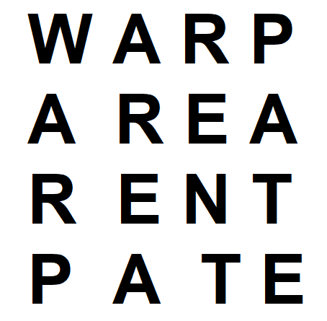

Kill the Buddha, body, baddie; it’s your
duty you see; your bootie for your dad-
dy, so your soul can wander free. The core
within the biddy is your buddy had

you known. It’s batty that the putty is
not potty but the zone. It’s not pretty
but it’s witty that we’re pieces in this quiz.
Your war within is fuzzy; this ditty

explains the biz. This paddy cake’s a sad-
ly take and madly offers zip, and bad-
ly pushes beady eyes and lies we glad-
ly quip. For you are who; it’s not a fad,

you know what’s no and yes; you’d better guess
what’s more than more, and what’s sure less than less.

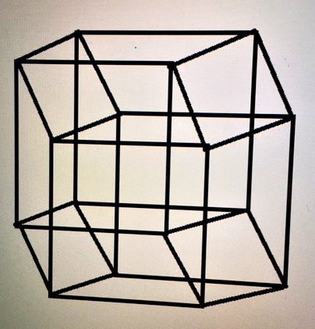

War is just a coffin lid and a door
to every tomb, a message harsh and un-
forgiving, unremitting doom. The poor
are always victims and are trampled one

by one, both in and out, while serving lords,
or targets of a gun. Regurgitat-
ing people is how destiny claims hoards,
just rototilling masses so their fate

is Hell’s rewards, a cosmic interven-
tion making pasts and futures fixed, while here
and now stay remedies for certain when
they’re mixed. It’s like your breath that’s ever near,

a pathway to your heart, it’s where you start
for Heaven’s bliss, with silence a la carte.

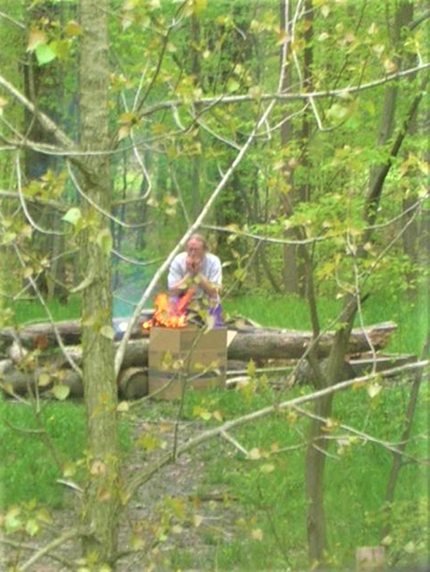
War’s ocean is a turbulence of crash-
ing violent waves, that eats up unsuspect-
ing souls and foregoes tombs and graves. It lash-
es out in all directions disrespect-

ing all, with no regard for livelihoods,
spring, summer, winter, fall. It’s like a pock-
et plague that strips all lands, and hearts and goods, and leaves all countries devastated, block-

ing blameless “shoulds,” those peaceful harmless “won-
derfuls” neglected during war, those things
that never happen when fiends violent un-
derscore, the need for tribulation, kings

who relish in Hell’s shit, and raise that pit: abomination, that won’t ever quit.

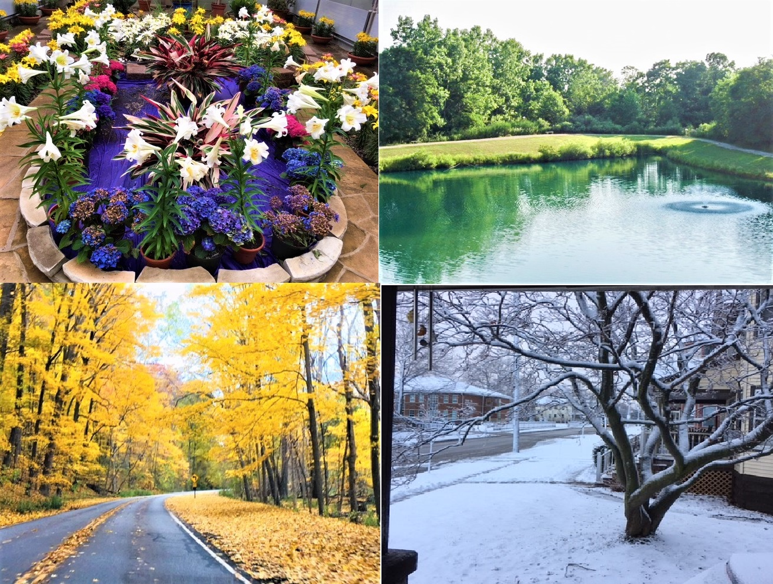

All war is raw, yes, rah, rah, rah, and har,
har, har it seems, both front and back, there is
no lack of sentient mastered schemes. Bizarre
as language often is we find a quiz

in words: for war from werre and guerre combined,
such weirdness placed for nerds, where wolves and gear,
now have a home, through war that’s so unkind.
You’d think that werewolves packing gear could smear

what’s so maligned. But war is on life’s ped-
estal, and far above demise. It’s gifts
beyond miraculous; you’d think what’s said
are lies. Invention that we get just lifts

all war to monstrous heights. There are no rights or wrongs with war, there are just blacks and whites.

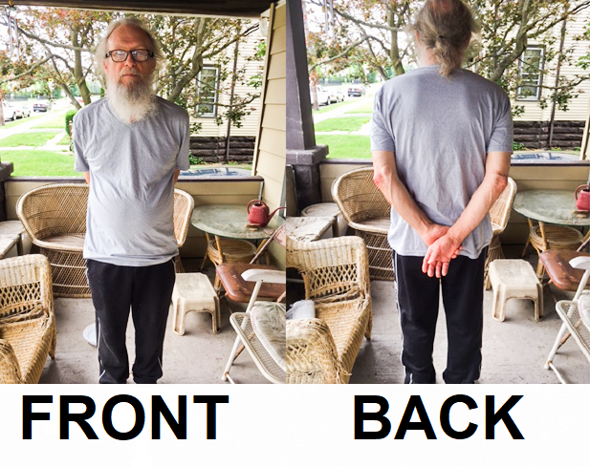

History may be written by victors
but war is written by money changers.
Wars are won by poor boys of grit. Pick wars
or pick peace; with peace there are no strangers,

just love and prosperity and equal-
ity. Do you know of a better cir-
cumstance? Those after money have a ball
with war, ever stroking conflicts to per-

fection, to haul in as much illicit
cash as they can. Lobbyists can not stop
their constant pursuit of weapons deals: fit
to plan, with back rooms, phone calls, emails, swap

and trade. There are just young lives at stake, hung out to dry in strange fields, for ballads sung.

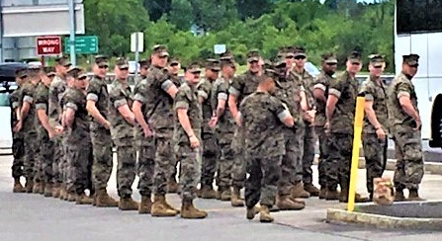

So War is an illusion, it has sil-
ly putty charm, like all things in this earth-
ly realm it seems to cause great harm. But real-
ly it’s a movie script on which all worth-

y souls, have acted parts they play for fun,
bit parts or mighty roles. Our souls sit back
observing all, untouched by all that’s none.
Reality is spirit and all lack

is unbegun. So wars are just festiv-
ities, just harmless and a dream. They don’t
exist, they are not real, they’re not what liv-
ing deem, as problematic as they won’t

impact what spirit needs: our wholesome deeds of heart to heart where light in life proceeds.

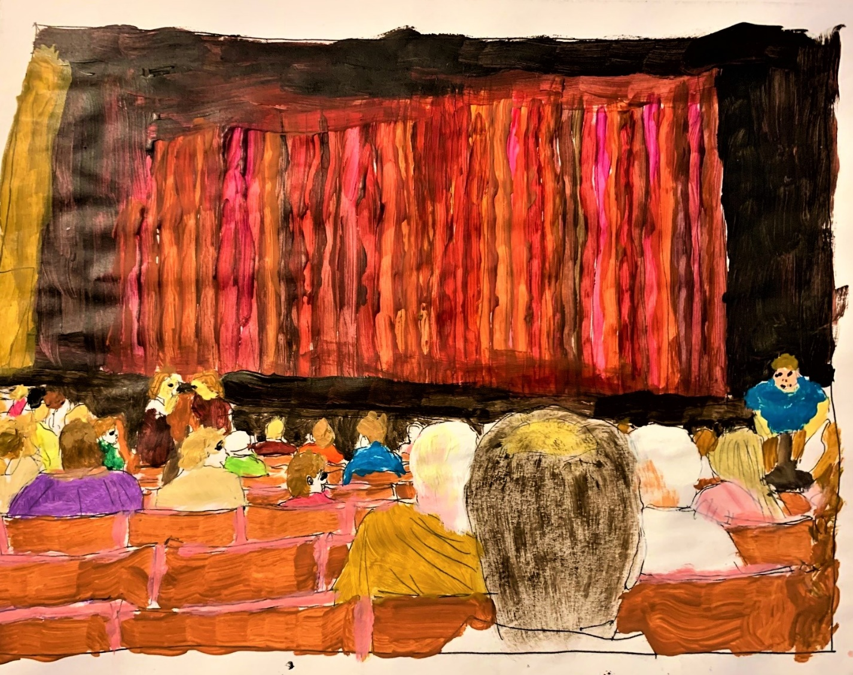

Wake up you little children there’s a means
for learning all. You need to be inside
yourselves, your mind is just a wall, that screens
you from your one true self that wants to guide

you home. Just listen to its silence as
it speaks to you of Om. Outside of you
are wars unceasing, noise like mindless jazz.
You need to turn your backs to it, pursu-

ing like a spaz, as if to reinvolve
you in diversions you should want. It cries
for your participation: its resolve
to haunt. Your choice is ever present, lies

will keep you from your goal, becoming whole
is why you’re here with all that is your soul.

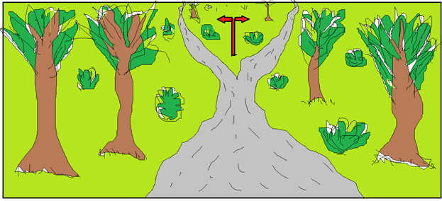

And then He does…

